
Predicting Cryptocurrency Prices Using
Machine Learning Algorithms

  - Final Report
Shahzad Ahmed
Student ID# 501211922

Table of Contents
Abstract 2
Literature Review 5
Introduction 5
Approach/Methodology 7
Exploratory Data Analysis (EDA) 8

Overview of the Data 8

The Augmented Dickey-Fuller (ADF) test 9

Data Visualization 11

Seasonal Decomposition of the Cryptocurrencies Close Price 11

Visualizing Market Capitalization 12

Visualizing the Closing and Opening Price Difference 12

Visualizing the High and Low-Price Difference 13

Python Package Loading and Data Cleaning 14

Data Dictionary 15

Missing Values 15

Univariate Analysis of High Prices 17

Bivariate Analysis 19

Statistical Summary for numerical columns 19

Correlation 21

Principal Component Analysis (PCA) 22

Comparison of original features model and the PCA model 24
Time-Series Forecasting 25

Simple Moving Average (SMA) 29

Exponential Smoothing (ES) 36

Autoregressive Integrated Moving Average (ARIMA) 42

Seasonal Autoregressive Integrated Moving Average (SARIMA) 51

Prophet 58

Deep Learning Techniques 62
Conclusion 71
Self Reflection 71
Reference 72

Abstract

Title:
Predicting Cryptocurrency Prices Using Machine Learning Algorithms.
With the advancement and modernization of technology, various industries are rapidly evolving to adapt to the latest global trends. One such change that has been taking place is the increasing prevalence of cryptocurrency as a medium of exchange and investment. This shift towards digital currencies represents a significant departure from traditional fiat currencies and stock exchange practices and It’s the time to understand what digital money really means for everyone’s future. I would like to direct the readers to an engaging article by Alex Hern that delves into the world of Bitcoin and cryptocurrencies, discussing their significance as digital currencies and their potential impact on our future. [1]
I have reviewed the article and identified five key takeaways:
- Cryptocurrencies, like Bitcoin, are a novel form of decentralized currency that allows individuals to exchange funds without the involvement of traditional financial institutions. This has the potential to disrupt the conventional banking system and reshape the financial landscape.
- Blockchain technology is the foundation behind cryptocurrencies, serving as a distributed ledger that records transactions and is maintained by a network of computers. It has the potential to be used for a broad range of applications beyond finance, including supply chain management, voting systems, and identity verification.
- Cryptocurrencies have been notorious for their high degree of volatility, with their worth fluctuating dramatically. This has raised concerns about their stability and long-term viability as a store of value.
- Despite providing some level of anonymity, cryptocurrencies have also been linked to illegal activities, such as money laundering and drug trafficking. As a result, governments and regulatory bodies have increased scrutiny of them.
- The advent of cryptocurrencies has ignited a broader discussion about the role of technology in society and its potential to disrupt established power structures. Although it remains to be seen how this will unfold, it is evident that cryptocurrencies and blockchain technology could have a significant influence on our future.
CB Insights [2] published an article that delves into the impact of blockchain technology on traditional banking and payment systems. The article highlights how blockchain technology can enable decentralized payment systems that facilitate faster and more secure transactions between financial institutions. This is important to our study as it sheds light on the potential influence of blockchain technology on the finance industry and how it could impact cryptocurrency prices. The article offers five key takeaways:
- Blockchain technology can disrupt the banking industry by making transactions faster, cheaper, and more secure, as it eliminates the need for intermediaries like banks to facilitate transactions.
- Financial institutions can reduce their dependence on traditional payment processors such as SWIFT by using blockchain technology to streamline cross-border payments. This can significantly reduce the cost and time involved in international transactions.
- Smart contracts, which are self-executing contracts where the terms of the agreement between buyer and seller are directly written into lines of code, can automate various aspects of financial transactions like loan origination and settlement. This has the potential to reduce costs and increase efficiency.
- Blockchain technology can enhance transparency and decrease fraud by providing an immutable and permanent record of transactions. This can help financial institutions monitor and prevent fraudulent activities.
- While the banking industry is still in the early stages of adopting blockchain technology, many financial institutions are exploring ways to incorporate this technology into their operations. Although there are technical and regulatory hurdles to overcome, the potential benefits of blockchain technology for the banking industry are significant.
Overall, both articles offer insights into the broader landscape of cryptocurrency and blockchain technology, which can help inform our study on predicting cryptocurrency prices using machine learning algorithms.
Research Questions:
What are the most effective predictive and time series analysis techniques for forecasting short-term closing prices of cryptocurrencies? Which features are influential predictors for classifying the short-term closing prices of selected cryptocurrencies?
What is the correlation between the predicted prices generated by machine learning algorithms and the actual prices of the chosen cryptocurrencies?
Scope of the Research:
The project aims to use machine learning algorithms to predict short-term closing prices of different cryptocurrency companies. The dataset for this project is obtained from Kaggle Inc. which contains historical data for the chosen cryptocurrencies. The objective is to compare the predicted prices with the actual prices and identify which cryptocurrency presents the most profitable opportunity for short-term trading.
To answer the research question, we will explore different machine learning algorithms and time-series analysis techniques, such as SMA, SE, ARIMA, SARIMA, PROPHET and deep learnings. We will compare the efficiency and stability of these techniques to identify the most effective ones for our purpose.
Data Source:
The data set used in this project is obtained from Kaggle Inc. which contains historical data for the chosen cryptocurrencies. The data is related to the closing prices of each of the six different cryptocurrency companies and has been used in previous researches.
Limitations of the Research:
The scope of this study is restricted to specific cryptocurrency companies and the historical data that is accessible for them, and thus, it may not accurately reflect the overall cryptocurrency market. The machine learning algorithms utilized in the analysis rely on historical data, and the future value of cryptocurrencies can be influenced by unpredictable factors, such as changes in regulations, market sentiment, and global events. The precision of the forecasts could be influenced by the quality and comprehensiveness of the data used.
Background Information:
Cryptography is used to secure cryptocurrency, which is a digital or virtual form of money. It is decentralised and not under the jurisdiction of a single entity, such as a government or bank, unlike conventional currencies. It is a distributed ledger used to record cryptocurrency transactions and is used to secure and authenticate user data. The worldwide financial system has been significantly impacted by this innovative technology, and its future growth potential is enormous. The first cryptocurrency, Bitcoin, was released in 2009, and since then, the market has expanded to encompass several other cryptocurrencies, with a market capitalization of over $1 trillion. Despite having only recently emerged, cryptocurrencies have already had a significant impact on the financial landscape and are predicted to continue doing so.
Specific Area of Research:
The specific area of research in this project is the utilization of machine learning algorithms in time-series analysis to predict the future prices of selected cryptocurrencies and identify profitable opportunities for short-term investment.
Data Set:
The project aims to use data to achieve the goal [5].
https://www.kaggle.com/datasets/sudalairajkumar/cryptocurrencypricehistory

Gethib Link of this Study:
https://github.com/shahgem/CIND-820

Literature Review
The emergence of cryptocurrencies has created an entirely new asset class that is characterized by high volatility and lack of regulation. As a result, the study of cryptocurrency markets has become increasingly important to both investors and financial analysts. The field of cryptocurrency price prediction has garnered significant attention, yet there is still a dearth of research papers on the subject. This shortage of information has motivated finance and data enthusiasts to explore the application of various deep machine learning models to market data.
Conventional time series techniques such as AutoRegressive Integrated Moving Average (ARIMA) have limitations in capturing the non-linear and non-stationary patterns that exist within cryptocurrency data, highlighting the need for alternative approaches. Deep learning methods have shown great promise in addressing these issues, owing to their ability to handle complex, high-dimensional datasets. Researchers agree that the frequent and high volatility of cryptocurrency prices can lead to underlying chaos, necessitating the use of Deep Learning Methods.
Several research papers have investigated which deep learning method is most accurate in forecasting cryptocurrency prices. Classification methods such as Random Forest Trees and k-folds were employed to compare the accuracy of each method. The studies have primarily focused on analyzing Bitcoin (BTC), given its status as the longest active currency for conducting analysis and its dominance in the cryptocurrency market.
The reviewed papers primarily investigate the performance differences of deep learning methods across various time intervals of cryptocurrency prices. These time intervals include daily, weekly, and monthly opening and closing prices. In addition to forecasting prices based on historical data, some studies have also incorporated sentiment analysis.
Researchers have analyzed the frequency of the term "Bitcoin" in tweets and explored its relationship to BTC predictability. However, it is worth noting that the utilization of natural language processing (NLP) methods for sentiment analysis is not relevant to this project.
Overall, the study of cryptocurrency price prediction is a nascent field that requires further research. Deep learning methods have shown great promise in addressing the unique challenges posed by cryptocurrency markets, and several studies have explored the application of these methods to BTC. This project aims to build on this research by investigating the performance of various deep learning methods for forecasting the prices of other popular cryptocurrencies.

Introduction
The field of cryptocurrency price prediction is an exciting and rapidly evolving area of research, with many promising avenues to explore. Given the newness of this topic, the number of research papers available is limited, making it an ideal area for finance and data enthusiasts to explore and experiment with various deep machine learning models.
Conventional time series techniques, such as ARIMA, have proved to be ineffective in capturing the non-linear and non-stationary patterns that are commonly present in cryptocurrency data. These limitations underscore the need for alternative approaches to analyze this unique and dynamic market.
One of the major challenges in predicting cryptocurrency prices is the high volatility and frequency of price fluctuations, which can lead to underlying chaos. As such, Deep Learning Methods have emerged as a critical tool in this field, as they can capture complex patterns in the data that other methods might miss.
In addition to analyzing the historical data of cryptocurrencies, researchers have also explored the role of sentiment analysis in price prediction. Some studies have analyzed the frequency of "Bitcoin" in tweets to determine if it correlates with the predictability of the BTC price, using Natural Language Processing (NLP) methods. However, this project will not consider sentiment analysis due to the limitations of the scope and the complexity of NLP techniques. One of the studies “Cryptocurrency Price Prediction Using Tweet Volumes and Sentiment Analysis” [3] concludes People who tweet about cryptocurrencies even when their prices drop have an interest in them beyond investment opportunity making the tweets biased towards positive. Here are five key points that can be gleaned from the paper:
- Cryptocurrency price prediction is an important area of research, and many different methods have been proposed to predict the price of cryptocurrencies, such as Bitcoin, Ethereum, and Litecoin.
- The authors propose a new method for cryptocurrency price prediction that uses tweet volumes and sentiment analysis. The method involves collecting and analyzing tweets related to specific cryptocurrencies and using the sentiment analysis of those tweets to predict the future price of the cryptocurrency.
- The study shows that tweet volumes and sentiment analysis can be useful in predicting cryptocurrency prices, and the method proposed by the authors outperforms other methods such as time series analysis and support vector regression.
- The authors note that their method is not without limitations, including the potential for bias in the data due to the selective nature of Twitter users and the need for further research to validate the results.
- Despite the limitations, the study highlights the potential of social media data and sentiment analysis in predicting cryptocurrency prices and suggests that further research in this area could lead to improved prediction models and better understanding of the cryptocurrency market.
In summary, this project aims to explore and evaluate the performance of several Deep Learning Methods to forecast the prices of cryptocurrencies. While researchers from Jaypee University of Information Technology, India have conducted extensive investigations on this topic [4]. Here are five key points from the project report on "Cryptocurrency Price Prediction Using Deep Learning":
- The project proposes the use of deep learning techniques to predict the price of cryptocurrencies, which are highly volatile and challenging to predict accurately.
- The project uses historical price data from popular cryptocurrencies like Bitcoin and Ethereum to train a deep learning model using various neural network architectures, including LSTM, GRU, and CNN.
- The project also explores the use of technical indicators, such as Moving Average Convergence Divergence (MACD) and Relative Strength Index (RSI), to improve the accuracy of the predictions.
- The project evaluates the performance of the model using various evaluation metrics such as Mean Absolute Error (MAE) and Root Mean Squared Error (RMSE), and shows that the deep learning model outperforms traditional statistical models in predicting cryptocurrency prices.
- The project provides valuable insights into the potential of deep learning techniques and technical indicators for predicting cryptocurrency prices and suggests further research in this area.
Notably, the data set we are going to use in this study, this same data set was employed in a previous study by a researcher Manomi Koroth, whose report is available at
https://github.com/Mkoroth97/CIND820-2021/blob/main/CIND820-FINAL%20REPORT.pdf
Upon analyzing the report, some potential limitations and avenues for enhancement were identified. For example, the report utilizes a basic linear regression model for predicting cryptocurrency prices, but fails to compare its performance with other machine learning models and techniques. To enhance the model's accuracy, experimenting with other models and techniques would be worth considering. Additionally, the report does not provide a comprehensive evaluation of the model's performance, such as mean absolute error, mean squared error, or R-squared. By incorporating these metrics, a more thorough assessment of the model's accuracy can be conducted, and areas for further improvement can be identified. These aspects will be addressed in this study.
I intend to offer a novel perspective by including additional insights in my literature review. My goal is to provide a more in-depth analysis of the dataset and explore the use of a wider range of model techniques to present readers with a more thorough and comprehensive analysis. Through this project, we hope to contribute to the growing body of research in this exciting and rapidly evolving field.

Approach/Methodology
Developing a robust approach for analyzing cryptocurrency market data is essential for investors seeking to gain insight into the cryptocurrency market and make informed investment decisions. The following steps outline a structured methodology for analyzing cryptocurrency market data:
Data Collection: The first step is to gather relevant historical price data for the cryptocurrencies being analyzed, including trading volume and market capitalization. The data must be sourced from reputable sources to ensure accuracy and reliability.
SWOT Analysis: Conducting a SWOT analysis of the selected models is crucial to identifying their strengths, weaknesses, opportunities, and threats. This analysis will help in determining which models are best suited for the specific cryptocurrency being analyzed.
Data Preparation: After collecting the data, the next step is to prepare it for analysis. This involves removing any missing or erroneous data, transforming the data into a suitable format, and normalizing it to account for differences in scale.
Model Selection: In this step, various models such as SMA, ARIMA, and Prophet models are selected as potential options for analysis. It is important to select the most appropriate models for the specific cryptocurrency being analyzed.
Model Implementation: Once the models are selected, they are implemented and applied to the prepared data. This may involve adjusting the parameters of the models to optimize their performance.
Data Visualization: Conducting exploratory data analysis (EDA) to understand the dataset's properties and characteristics is essential. Techniques such as box plots and histograms are used to detect outliers, distributions, and correlations. EDA helps in identifying trends, patterns, and potential relationships between the features of the dataset.
Model Evaluation: Evaluating the models' performance is crucial in determining their accuracy and reliability and identifying areas for improvement. Appropriate metrics such as mean absolute error (MAE), root mean squared error (RMSE), and mean absolute scaled error (MASE) are used in this step.
Results Interpretation: The results of the analysis are interpreted and conclusions are drawn based on the findings. This may involve visualizing the data and model outputs using graphs and charts, as well as conducting statistical tests to assess the significance of the results.
Conclusion and Recommendations: The key findings of the study are summarized, and recommendations for future research or actions are provided based on the results. By following this structured methodology, investors can make informed decisions based on reliable data analysis. The methodology outlined here is an essential tool for any investor looking to gain a competitive edge in the cryptocurrency market, as it provides a comprehensive and systematic approach for analyzing cryptocurrency market data.

Exploratory Data Analysis (EDA)

Overview of the Data
The dataset utilized in this project was sourced from Kaggle Inc, and is publicly accessible under the title "Cryptocurrency Historical Prices" [5].
During this course of study, I will emphasis on Bitcoin (BTC), Ethereum (ETH), Litecoin (LTC), Dogecoin (DOGE), Cardano (ADA), and Binance Coin (BNB). Although Kaggle provides separate CSV files for each cryptocurrency, the author of this project has amalgamated all the individual files into a single CSV file named "crypto_market.csv". This amalgamation was possible due to the identical columns of each file, i.e., Serial Number, Name, Symbol, Date, High, Low, Open, Close, Volume, Market Capitalization.
The initial dataset brings to the fore the non-uniformity of the trading dates of the various currencies. As previously noted, BTC has been in circulation for the longest period, pre-dating all the other cryptocurrencies in the dataset. Since the start dates for each currency, which may significantly impact their predicted prices. To mitigate this potential bias, it is advisable to limit the analysis to the period from 2017 onwards, as this provides a more consistent and recent historical data for all the selected currencies. This filtered dataset has been saved under the file name "sixcryto.csv".
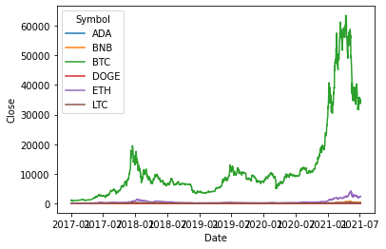
In light of this, during the analysis phase of this project, it is prudent to compare all currencies from 2017 onwards, so as to minimize prediction bias and incorporate a more uniform and recent historical data.

The Augmented Dickey-Fuller (ADF) test
The Augmented Dickey-Fuller (ADF) test is a statistical test that aims to determine the stationarity of a given time series. Stationarity refers to the property of a time series in which its statistical characteristics, such as the mean and variance, remain constant over time. This is a crucial assumption in many time series models, as it simplifies the analysis and interpretation of the data.
As a unit root test, the ADF test examines whether a unit root exists in the time series, which is a characteristic of a non-stationary time series that tends to drift over time and does not revert to its mean. The ADF test compares the differences between the observed values in the time series and the expected values if the series were stationary. If the differences are significant enough, the null hypothesis of a unit root is rejected, indicating that the time series is stationary.
The ADF test is based on the augmented Dickey-Fuller regression model, which is a linear regression model that includes lagged differences of the time series as explanatory variables. The ADF test examines the coefficient of the lagged first difference in the regression equation, which represents the rate at which the time series reverts to its mean.
The ADF test has several variations, including the ADF test with a constant and trend term, which allows for a linear trend in the time series. The ADF test can also be applied to seasonal time series, where the seasonal differences are included in the regression equation.
An article on “Augmented Dickey Fuller Test (ADF Test) – Must Read Guide” [ ] by Selva Prabhakaran, explains that
- it’s a statistical technique employed to assess whether a time series is stationary. Stationary time series remain consistent in their mean and variance over time, resulting in simpler analysis and modeling.
- The ADF test postulates a null hypothesis that the time series contains a unit root and is non-stationary. The test generates a p-value, which determines the probability of obtaining the observed test statistic under the null hypothesis. If the p-value is less than the pre-defined significance level (usually 0.05), the null hypothesis is rejected, and the time series is deemed stationary.
- an example of performing the ADF test utilizing the Python's statsmodels library is demonstrated, which involves using a dataset containing the daily closing prices of the S&P 500 index from 2000 to 2021.
- Additionally, the article explains the commonly used technique of first-order differencing to convert a non-stationary time series into a stationary one, which involves computing the difference between consecutive observations.
- Finally, the article acknowledges some limitations of the ADF test, such as its sensitivity to the selection of lag length and the assumption of no seasonality. The article recommends using additional tests in conjunction with the ADF test to obtain a more robust assessment of stationarity.

ADF test results for LTC:  ADF Statistic: -2.7082134836981204  p-value: 0.0726277298789853  Critical Values:  1%: -3.4343880265995215  5%: -2.8633235546096194  10%: -2.56771952639493 | ADF test results for ADA:  ADF Statistic: -0.36685973652723514  p-value: 0.9154867070335785  Critical Values:  1%: -3.4352067731212785  5%: -2.863684892975246  10%: -2.5679119438718847
ADF test results for BNB:  ADF Statistic: -1.1927352624028085  p-value: 0.6767129850848179  Critical Values:  1%: -3.434973278556316  5%: -2.8635818545830376  10%: -2.567857072940785 | ADF test results for DOGE:  ADF Statistic: -2.5046236471718837  p-value: 0.11435339083070933  Critical Values:  1%: -3.4343880265995215  5%: -2.8633235546096194  10%: -2.56771952639493
ADF test results for ETH:  ADF Statistic: -0.2946680285065856  p-value: 0.9262561114893395  Critical Values:  1%: -3.4343855346462084  5%: -2.863322454682502  10%: -2.567718940693489 | ADF test results for BTC:  ADF Statistic: -0.8534254391161623  p-value: 0.8029231087997073  Critical Values:  1%: -3.4343880265995215  5%: -2.8633235546096194  10%: -2.56771952639493
The ADF test outcomes contain insights about the stationarity of each cryptocurrency's time series. The ADF test's null hypothesis is that the time series is non-stationary and has a unit root. If the p-value is below the chosen significance level (often 0.05), the null hypothesis is rejected, indicating that the time series is stationary.
Based on the ADF test results, it is evident that the p-values for all the cryptocurrencies are greater than 0.05. As a result, we fail to reject the null hypothesis, and we cannot claim that any of the cryptocurrencies have a stationary time series.
The ADF Statistic value in the ADF test is a measure of how much the time series deviates from being stationary. It indicates the extent of non-stationarity in the time series. A more negative ADF statistic value provides stronger evidence against the null hypothesis of stationarity.
To summarize, based on the ADF test results, it is indicated that the time series of each cryptocurrency might not be stationary. The results show that none of the cryptocurrencies have p-values less than the significance level of 0.05, which indicates that we cannot reject the null hypothesis of non-stationarity. Additionally, the ADF Statistic values are not more negative than their respective critical values, which also supports the conclusion of non-stationarity.
In conclusion, the ADF test is a powerful tool for testing the stationarity of time series data. It is widely used in many areas of research, including finance, economics, and environmental science. The ADF test provides a robust and reliable method for testing the null hypothesis of a unit root in a time series, allowing researchers to make informed decisions about the statistical properties of their data.

Data Visualization

Seasonal Decomposition of the Cryptocurrencies Close Price
Seasonal decomposition is a technique used in time series analysis to separate a time series into its underlying components: trend, seasonal, and residual. The trend component represents the long-term progression of the time series, the seasonal component captures the repeating patterns that occur over shorter periods of time (e.g., days, weeks, months, seasons), and the residual component represents the random fluctuations or noise that cannot be explained by the trend or seasonal components.
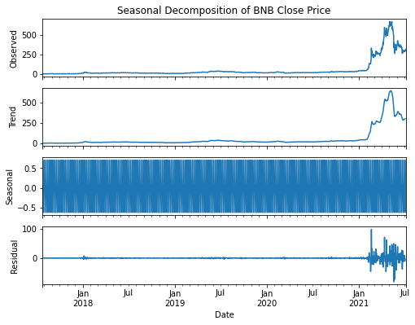
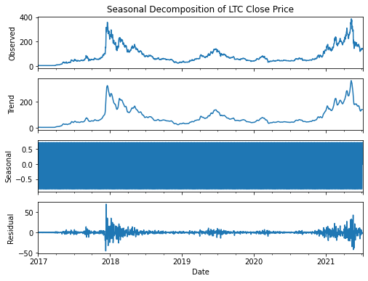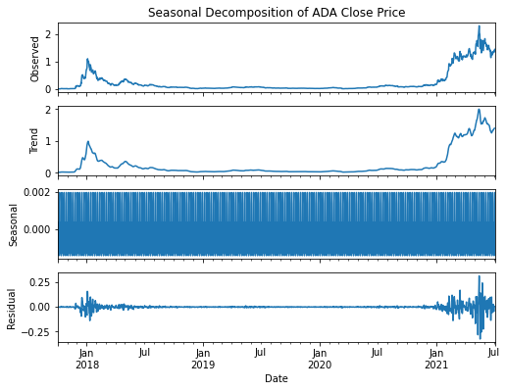
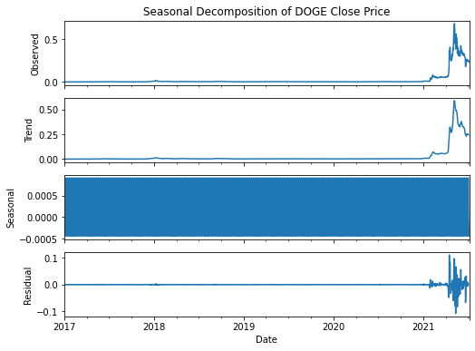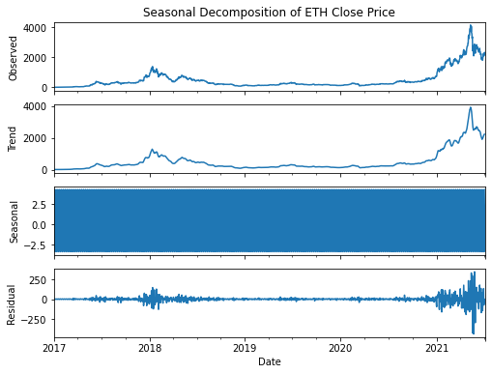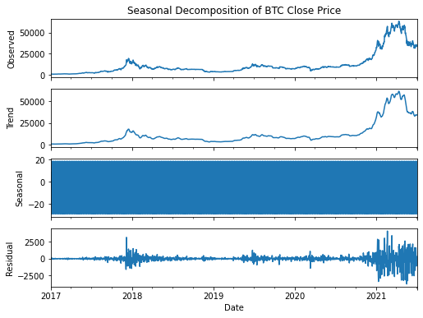
The goal of seasonal decomposition is to gain a better understanding of the underlying structure of the time series and to identify any patterns or trends that may exist. This can be useful for making predictions about future values of the time series, as well as for identifying potential relationships between the time series and other variables.

Visualizing Market Capitalization
The initial step in our analysis involved segregating the dataset by individual currencies, in order to facilitate comparative visualization. The determination of which currency held the greatest sway in the market was predicated on market capitalization - a metric that reflects the total market value of a given currency. Given Bitcoin's pioneering role in the cryptocurrency space, and its established longevity, we hypothesized that it would exert the greatest impact on the market.
However, the lack of market capitalization data prior to 2017 posed a challenge to our analysis. To overcome this, we chose to graph market capitalization data starting from the year 2017. This approach allowed us to focus on a more recent and reliable dataset.
The resulting graph illustrated that Bitcoin was the most frequently traded currency, with its market capitalization dwarfing that of its peers. This observation was consistent with our hypothesis, indicating that Bitcoin indeed exerted a significant influence on the cryptocurrency market.
Furthermore, the graph revealed that as Bitcoin prices increased, so too did the prices of other currencies. This suggested a strong correlation between Bitcoin's market performance and that of other cryptocurrencies. In other words, Bitcoin appeared to be a bellwether of sorts - with its price movements influencing the direction of other currencies.
These findings were consistent with existing literature on the topic, which posited that Bitcoin's market performance had a significant impact on the performance of other cryptocurrencies. Thus, our analysis helped corroborate and extend this prior research, shedding light on the interdependence of the cryptocurrency market and the key role played by Bitcoin within it. 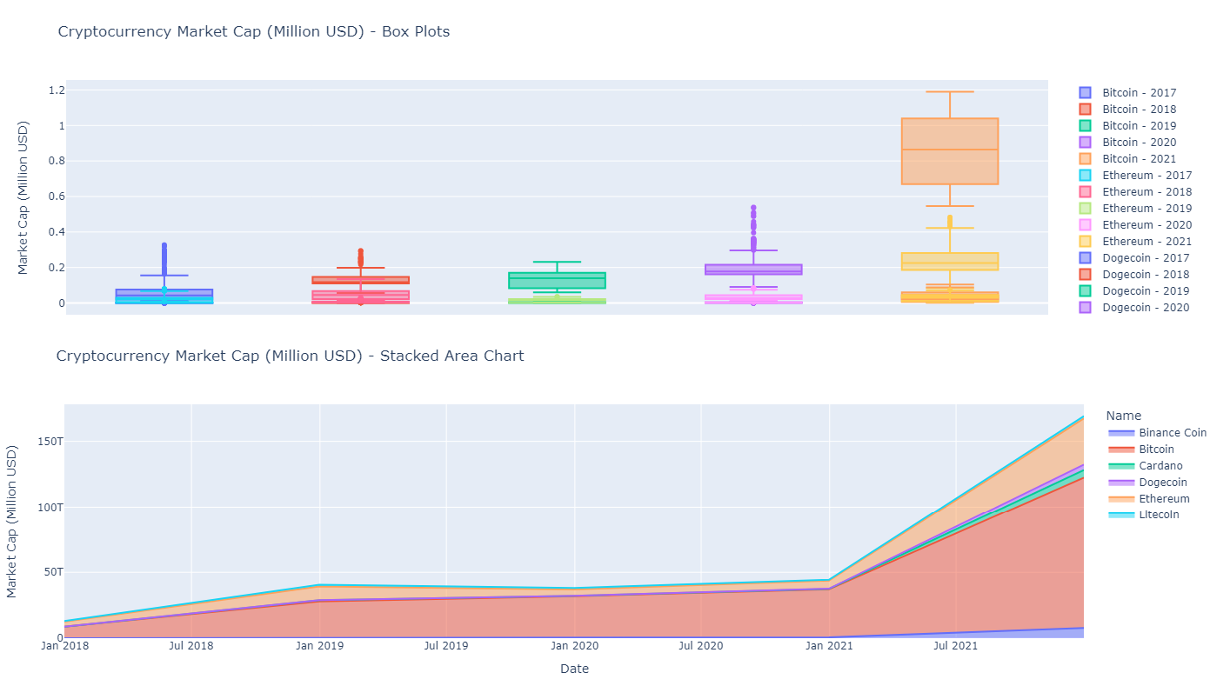

Visualizing the Closing and Opening Price Difference
To gain a better understanding of the daily price trends for each cryptocurrency, I examined the difference between the opening and closing prices for each data point. This provides insight into the level of price fluctuation that occurred during each trading day.
Upon analyzing the data, it became clear that Bitcoin experienced the highest price fluctuations from opening to closing in a day. This is consistent with Bitcoin's reputation for volatility and its tendency to experience sudden price surges or drops.
However, it's important to note that other cryptocurrencies also exhibited significant price fluctuations. Ethereum, for example, demonstrated a high level of price variation, which is not surprising given its status as the second most traded crypto project since its inception in 2017.
Furthermore, the graph reveals an interesting relationship between price increases and price fluctuations. Specifically, as the overall cryptocurrency market experiences price increases, the degree of price fluctuation tends to also increase. This can be attributed to various factors, such as increased investor speculation and market hype, which can lead to more volatile trading patterns.

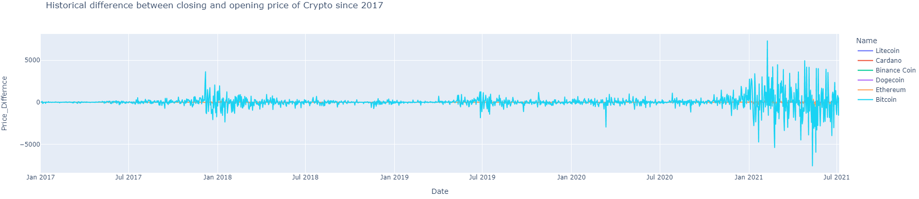

In summary, the analysis of the difference between opening and closing prices provides valuable insights into the daily price trends for each cryptocurrency. Bitcoin and Ethereum are among the most volatile, while the level of price fluctuation tends to increase alongside price increases in the overall market.

Visualizing the High and Low-Price Difference
One of the key factors driving interest in cryptocurrencies is their price volatility. This volatility is often attributed to the limited supply of cryptocurrencies and the speculative nature of their value. As with any asset, the price of cryptocurrencies is influenced by supply and demand, with market participants often reacting to news and events that impact the cryptocurrency ecosystem.
In our analysis, we sought to understand the daily price variations of cryptocurrencies and the differences between their high and low prices. To accomplish this, we first calculated the daily price spread of each cryptocurrency by subtracting the low price from the high price. Our analysis revealed that Bitcoin and Ethereum exhibit the most significant price fluctuations, while other cryptocurrencies showed a relatively plateaued trend. This suggests that Bitcoin and Ethereum may be subject to greater volatility than their counterparts.
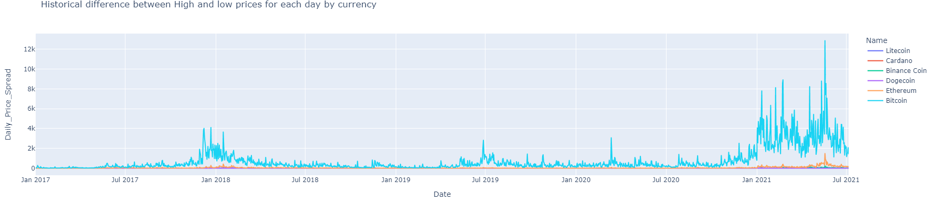
In addition to analyzing the daily price variations of cryptocurrencies, we also examined the activity levels of each currency. Our analysis found that 2018 was the most active year for Bitcoin, while the post-pandemic period has seen a significant uptick in cryptocurrency activity. We hypothesize that this increase in activity may be attributed to a rise in unemployment during the pandemic, leading individuals to explore alternative means of income generation.
These findings underscore the importance of monitoring the price fluctuations and activity levels of cryptocurrencies. Understanding the factors that drive these fluctuations can provide valuable insights for investors and policymakers alike. Additionally, our analysis highlights the potential of cryptocurrencies as an alternative asset class for individuals looking to diversify their investment portfolios.
However, it is important to note that cryptocurrencies remain a relatively new and untested asset class, and their volatility and lack of regulation can create significant risks for investors. Furthermore, the regulatory landscape for cryptocurrencies remains uncertain, with many countries struggling to develop coherent policies around their use and adoption. Future research may explore the relationship between cryptocurrency price fluctuations and macroeconomic factors, such as unemployment rates and economic policy changes, to gain a more comprehensive understanding of these emerging financial instruments.

Python Package Loading and Data Cleaning
Python was chosen as the programming language for this project due to its versatility and the availability of numerous packages for basic statistical analysis and building complex time series models. The following packages were loaded for data cleaning, preparation, building, and plotting the dataset: Numpy, Pandas, Sklearn, Prophet, Seaborn, Sarimax, and Mathplotlib.
Pandas profiling is a powerful tool for automating the process of data profiling, which involves generating a comprehensive report of the dataset's characteristics and statistics. The library offers a wide range of features and customization options for generating informative and visually appealing reports. In this article [6], this delve into the capabilities of Pandas profiling and explore some advanced use cases and integrations that can be leveraged to produce compelling reports from data frames. By utilizing this tool, data analysts and scientists can gain a deeper understanding of their data and communicate insights effectively to stakeholders. Please find below a summary of Panda's profiling of the primary attributes of our dataset, provided for the reader's reference.

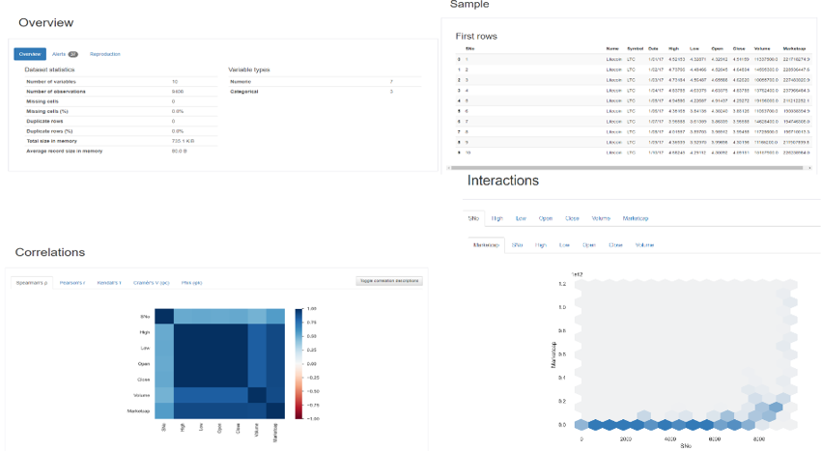
Further exploratory analysis was conducted using Pandas Profiling. The detailed report can be found at https://github.com/shahgem/CIND-820/blob/main/CryptoAnalysis.html

Data Dictionary
The dataset can be described briefly as follows.
Column | Explanation | Variable Type | Data Type
Sno | Serial Numbers | Numerical (Nominal) | int64
Name | Name of the currency | Categorical (Nominal)) | object
Symbol | Symbol or abbreviation of the cryptocurrency | Categorical (Nominal) | object
Date | Phone number of customer | Date(datetime) | object
High | Highest price of the cryptocurrency on the given date | Numerical (continuous) | float64
Low | Lowest price of the cryptocurrency on the given date | Numerical (continuous) | float64
Open | Opening price of the cryptocurrency on the given date | Numerical (continuous) | float64
Close | Closing price of the cryptocurrency on the given date | Numerical (continuous) | float64
Volume | Volume of the cryptocurrency traded on the given date | Numerical (continuous) | float64
Marketcap | Market capitalization of the cryptocurrency on the given date | Numerical (continuous) | float64

Missing Values
After reading the “Sixcrypto” dataset into a Pandas dataframe (“df”), we’ve captured a snapshot of the data with 10 columns, 9408 rows:
<class 'pandas.core.frame.DataFrame'>
RangeIndex: 9408 entries, 0 to 9407
Data columns (total 10 columns):
# Column Non-Null Count Dtype
--- ------ -------------- -----
0 SNo 9408 non-null int64
1 Name 9408 non-null object
2 Symbol 9408 non-null object
3 Date 9408 non-null object
4 High 9408 non-null float64
5 Low 9408 non-null float64
6 Open 9408 non-null float64
7 Close 9408 non-null float64
8 Volume 9408 non-null float64
9 Marketcap 9408 non-null float64
dtypes: float64(6), int64(1), object(3)
memory usage: 735.1+ KB
Counting the number of missing values for each column by df.isna().sum().
SNo 0
Name 0
Symbol 0
Date 0
High 0
Low 0
Open 0
Close 0
Volume 0
Marketcap 0
dtype: int64
Counting the number of duplicated rows for the dataset by df.duplicated().value_counts()
False 9408
dtype: int64
Our analysis of the dataset revealed that there are no instances of missing values or duplicates. This indicates that the dataset is complete and unique.

Univariate Analysis of High & Close Prices
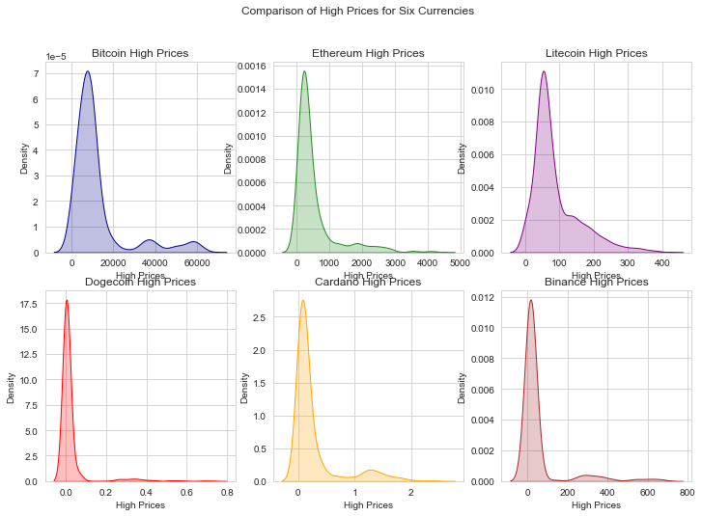
As we can see, our graphs are skewed to the right (positive skew).
Skewness is a statistical measure that indicates the degree of asymmetry of a distribution. It tells you whether the distribution is symmetric or not, and if it is not symmetric, it tells you whether the tail of the distribution is longer on the left or the right side.
A skewness value of 0 indicates a perfectly symmetric distribution, while a positive skewness value indicates a longer tail on the right side of the distribution, and a negative skewness value indicates a longer tail on the left side of the distribution.
Skewness can be useful in understanding the underlying data, as it can indicate whether there are outliers or unusual data points that may be affecting the distribution. It can also help in choosing appropriate statistical methods for analyzing the data, as some methods assume a normal distribution and may not be appropriate for skewed data.
Symbol Skewness
0 BTC 2.318963
1 ETH 2.672445
2 LTC 1.608763
3 DOGE 4.826529
4 ADA 2.389419
5 BNB 3.343639
Based on the results, it seems that the "High" prices distribution for DOGE has the highest skewness value (4.826529), indicating a significant degree of positive skewness, which suggests that there are more observations with smaller values (left tail) and fewer observations with larger values (right tail). Similarly, BNB also has a high skewness value (3.343639), indicating a degree of positive skewness. The other cryptocurrencies (BTC, ETH, LTC, and ADA) also have positive skewness values, indicating a similar pattern of more small values and fewer large values, but to a lesser extent compared to DOGE and BNB.
In summary, the skewness values suggest that the "High" prices distribution for these cryptocurrencies are skewed to the right (positively skewed), indicating that there are more observations with smaller values and fewer observations with larger values.
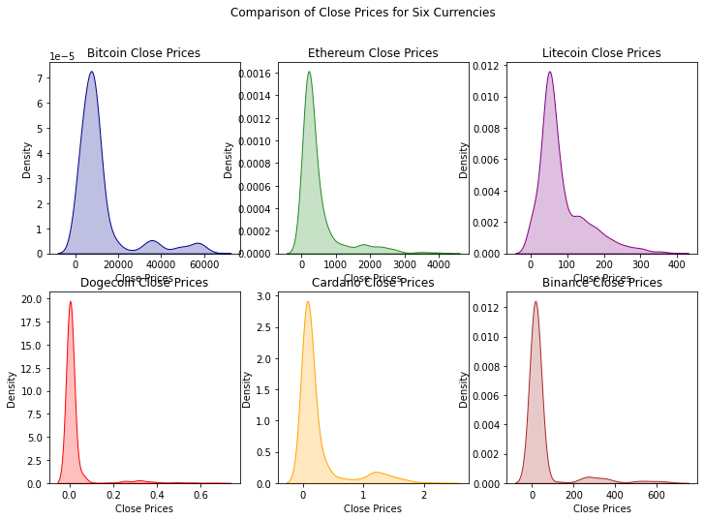
Symbol Skewness
0 BTC 2.331511
1 ETH 2.642688
2 LTC 1.560778
3 DOGE 4.701561
4 ADA 2.378311
5 BNB 3.359945
Based on the Skewness values of Close pirce, it appears that DOGE has the highest degree of positive skewness, followed by BNB, ETH, BTC, ADA, and LTC. This suggests that the distributions of daily returns for these cryptocurrencies are not symmetric and have a long right tail. This means that there is a greater probability of large positive returns compared to large negative returns for these cryptocurrencies.
By knowing the skewness of a distribution, investors can better estimate whether the future returns of an asset will be higher or lower than its past returns. This information is helpful in making investment decisions and managing risk. For example, if the skewness is positive, investors might expect to see more large gains in the future and may consider investing in the asset. Conversely, if the skewness is negative, investors might expect to see more large losses in the future and may decide to avoid investing in the asset.

Bivariate Analysis
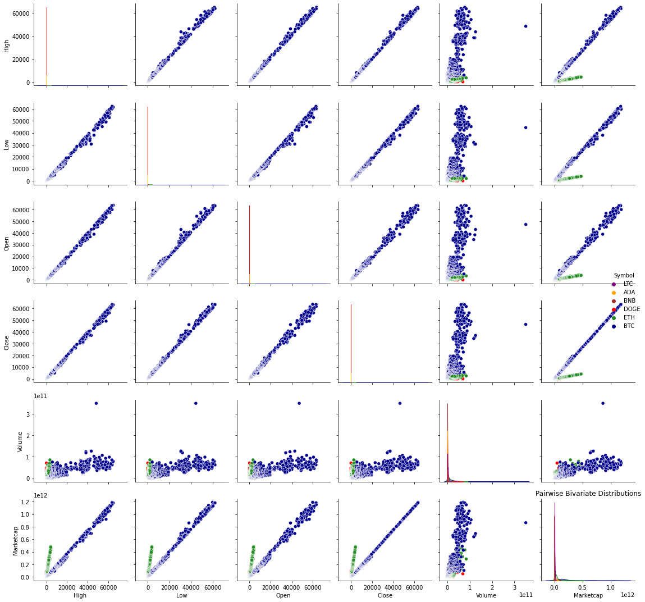
Bivariate analysis is a statistical method used to examine the relationship between two variables. In the context of the sixcrypto.csv dataset, bivariate analysis could be used to explore the relationships between different cryptocurrency variables, such as the relationship between the price and volume of each cryptocurrency.

Statistical Summary for numerical columns
df.describe().transpose() is a Pandas method that provides descriptive statistics for a DataFrame. The describe() method computes summary statistics such as count, mean, standard deviation, minimum, and maximum values for numerical columns in the DataFrame. The transpose() method then switches the rows and columns of the resulting DataFrame, making the statistics for each column appear as rows instead of columns. This makes it easier to interpret the summary statistics for each feature in the dataset, as we can view them side by side rather than having to scan across multiple columns. In summary, df.describe().transpose() is a convenient way to obtain a quick overview of the summary statistics for each feature in a DataFrame.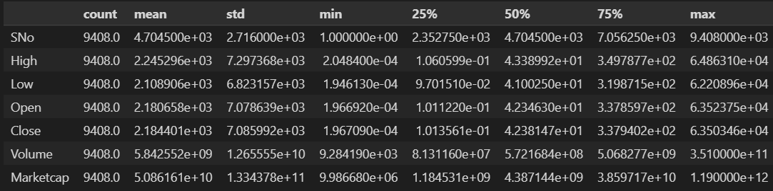
The output of df.describe().transpose() provides a summary of the key statistical measures for each numerical column in the dataset. The count row indicates the number of non-missing values in each column.
The mean row shows the average value for each column, while the std row indicates the standard deviation, or the amount of variation, in each column's values. The min and max rows show the smallest and largest values in each column, respectively.
The 25%, 50%, and 75% rows represent the first quartile (Q1), median, and third quartile (Q3) of the data distribution, respectively. These values can be used to assess the spread of the data, identify potential outliers, and evaluate the skewness of the distribution.
Based on the output, it can be observed that the dataset has 9,408 observations and 6 numerical features. The Volume and Marketcap features have the highest mean and standard deviation values, indicating significant variability in the data. Meanwhile, the SNo feature represents a sequential identifier for each observation, while the remaining features (High, Low, Open, and Close) represent the price data of a financial asset. The range of values for these price features is quite large, as evidenced by the large difference between the min and max values.
The high, low, open, and close columns represent the daily price of the cryptocurrencies, with mean values of 2.245296e+03, 2.108906e+03, 2.180658e+03, and 2.184401e+03, respectively. The standard deviations are relatively large, indicating a wide variability in the price movements. The minimum and maximum values of the high, low, open, and close columns are 2.048400e-04 and 6.486310e+04, respectively.
The volume column represents the daily trading volume of the cryptocurrencies, with a mean of 5.842552e+09 (SD = 1.265555e+10). The trading volume exhibits a positively skewed distribution, as evidenced by the median value (50%) of 5.721684e+08 being much lower than the mean value. The minimum and maximum values of the volume column are 9.284190e+03 and 3.510000e+11, respectively.
The Marketcap column represents the market capitalization of the cryptocurrencies, with a mean of 5.086161e+10 (SD = 1.334378e+11). The market capitalization also exhibits a positively skewed distribution, with the median value (50%) of 4.387144e+09 being much lower than the mean value. The minimum and maximum values of the Marketcap column are 9.986680e+06 and 1.190000e+12, respectively.
Overall, the df.describe().transpose() output provides a quick summary of the key statistics for each numerical feature in the dataset, which can be used to gain insights into the data distribution and identify potential issues or patterns in the data.

Correlation
Correlation is a statistical measure that indicates the strength and direction of the linear relationship between two variables. It is used to determine how closely related two variables are to each other. Correlation coefficients range from -1 to 1, where -1 indicates a perfect negative correlation, 0 indicates no correlation, and 1 indicates a perfect positive correlation. A positive correlation coefficient indicates a positive linear relationship between the two variables, while a negative correlation coefficient indicates a negative linear relationship. The strength of the correlation can be inferred from the absolute value of the correlation coefficient, with values closer to 1 indicating a stronger correlation. Correlation analysis is useful for identifying potential relationships or dependencies between different features in a dataset, which can be useful for subsequent data analysis and modeling.
- The Python code loads a dataset from a CSV file named "sixcrypto.csv" using the Pandas read_csv() function, creating a DataFrame object named df. The num_cols variable is then used to select only the numerical columns from the df DataFrame, namely Open, High, Low, Close, Volume, and Marketcap. A new DataFrame named num_df is created to hold only these selected numerical columns.
- Next, the correlation matrix between these numerical columns is calculated using the corr() method on the num_df DataFrame. The correlation matrix is a square matrix that shows the pairwise correlations between all pairs of numerical features in the dataset. A correlation coefficient is a statistical measure that indicates the strength and direction of the linear relationship between two variables. Correlation coefficients range from -1 to 1, where -1 indicates a perfect negative correlation, 0 indicates no correlation, and 1 indicates a perfect positive correlation.
- Finally, the correlation matrix is printed to the console using the print() function.
Open High Low Close Volume Marketcap
Open 1.000000 0.999546 0.999109 0.998901 0.749004 0.968995
High 0.999546 1.000000 0.999053 0.999525 0.750852 0.969801
Low 0.999109 0.999053 1.000000 0.999423 0.744467 0.969238
Close 0.998901 0.999525 0.999423 1.000000 0.748179 0.970084
Volume 0.749004 0.750852 0.744467 0.748179 1.000000 0.807050
Marketcap 0.968995 0.969801 0.969238 0.970084 0.807050 1.000000
The correlation results show a strong positive correlation among the variables, with correlation coefficients ranging from 0.749 to 1.000. The strongest correlation is observed between the High and Close variables (correlation coefficient of 0.999525), followed by the correlation between the Low and Close variables (correlation coefficient of 0.999423). The Volume variable has a weaker correlation with the other variables (correlation coefficients ranging from 0.744 to 0.750).
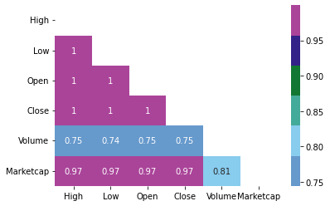
Based on the correlation results, it appears that the different cryptocurrency price features (Open, High, Low, Close, Volume, and Marketcap) exhibit a high degree of interdependence. The correlation coefficients between the variables range from 0.749 to 0.970, indicating a strong positive relationship between them. This finding has important implications for modeling and forecasting cryptocurrency prices, as it suggests that using all of these variables together may result in redundancy or multicollinearity in the data. In other words, it may be challenging to determine the relative importance of each feature in predicting cryptocurrency prices accurately.
To overcome this challenge, further analysis could be conducted to explore the direction and strength of causal relationships among the variables. Such analysis could provide insights into the underlying mechanisms that drive cryptocurrency price movements and help identify the most critical factors to consider in forecasting future price trends. Additionally, external factors that influence cryptocurrency prices, such as economic and political events, could also be examined to determine their impact on price movements. By considering both the internal and external factors that affect cryptocurrency prices, more accurate and reliable forecasting models could be developed.

Principal Component Analysis (PCA)
To explore this further, we may want to consider conducting a principal component analysis (PCA) on the data to identify the most important features and reduce the dimensionality of the dataset.
Principal Component Analysis (PCA) is a commonly used technique in data analysis and machine learning for reducing the dimensionality of high-dimensional data while retaining as much information as possible. The main goal of PCA is to transform a large set of correlated variables into a smaller set of uncorrelated variables (called principal components) while preserving the most important information.
Here are Here are some key points covered in the article written by Matt Brems[7]:
- PCA is a mathematical technique that transforms high-dimensional data into a lower-dimensional space while retaining the most important information.
- PCA is useful for reducing the complexity of data, identifying patterns and relationships between variables, and improving the performance of machine learning models.
- The article provides a step-by-step guide to performing PCA using Python, including data preprocessing, PCA implementation, and visualizing the results.
- The article also covers important concepts related to PCA, such as variance, covariance, eigenvectors, and eigenvalues.
- The article provides practical examples of using PCA in real-world scenarios, such as image processing and finance.
- The article discusses some common pitfalls and limitations of PCA, such as the interpretability of the results and the assumption of linearity.
In this test, we first load the data and select the features to use in PCA. Then, we standardize the data to ensure that each feature has a mean of zero and a standard deviation of one. We then perform PCA with two principal components and create a new data frame with these components. Finally, we concatenate the new data frame with the original data and visualize the results using Plotly. The resulting plot shows the cryptocurrency data projected onto the first two principal components, with each point colored according to the name of the cryptocurrency.
Here's a step-by-step breakdown of what the python code does to visualize PCA components:
- Import necessary libraries - Pandas, Sklearn, and Plotly.
- Load the cryptocurrency dataset (in CSV format) into a Pandas dataframe, where 'Date' column is set as index and parsed as datetime format.
- Select the numerical features ('Open', 'High', 'Low', 'Close', 'Volume', 'Marketcap') from the dataframe and convert them to a numpy array using the Pandas.values method.
- Standardize the features by scaling them to zero mean and unit variance using the Sklearn StandardScaler method.
- Perform PCA on the standardized features, setting the number of components to 2. This will transform the dataset into a 2-dimensional space by finding the 2 most informative linear combinations of the original features.
- Create a new Pandas dataframe with the 2 principal components, naming the columns 'PC1' and 'PC2', and setting the index to be the same as the original dataframe's index.
- Concatenate the new dataframe with the original dataframe along the columns axis, resulting in a new dataframe that has the principal components added as additional columns.
- Visualize the results using Plotly's scatter plot functionality. Each point represents a single day of cryptocurrency trading, and is colored based on the cryptocurrency name. The X and Y coordinates of each point represent the values of the first and second principal components, respectively.
Overall, this code provides a useful way to visualize the cryptocurrency dataset in a lower-dimensional space using PCA. It can help identify patterns or relationships between the different cryptocurrencies that might be harder to detect in the original higher-dimensional feature space.
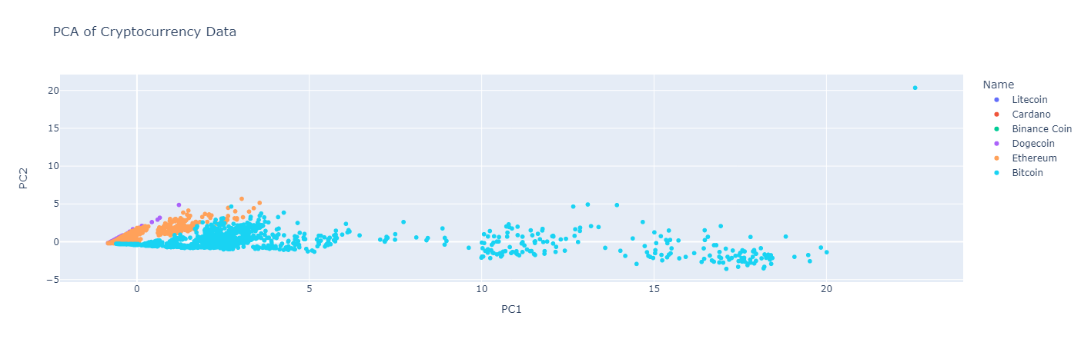
To compare the performance of the model using the original features versus the principal components, we can use a performance metric such as accuracy, mean squared error, or R-squared. We can use the same machine learning algorithm for both cases and train and test the models using the original features and the principal components separately.
We split our dataset into training and testing sets, then train a linear regression model on the training set using the original features and another model using the principal components. Next, we can evaluate the performance of each model on the testing set using the same performance metric.
We can then compare the performance of the two models and determine which approach yields better results. If the performance of the model using the principal components is comparable or better than the model using the original features, we can consider using the principal components for our analysis to reduce multicollinearity and potentially improve the interpretability and performance of our model.

Comparison of original features model and the PCA model
This Python code below performs a comparison of a linear regression model trained on the original features and a linear regression model trained on the principal components obtained through PCA.
First, the data is loaded from a CSV file and the original features are selected. Then, the data is split into training and testing sets. A linear regression model is trained on the original features using the training set and is used to make predictions on the testing set. The performance of this model is evaluated using mean squared error, mean absolute error, R-squared, and adjusted R-squared.
Next, the data is standardized and PCA is performed to obtain two principal components. A new dataframe is created with the principal components, which is then concatenated with the original dataframe. The concatenated dataframe is split into training and testing sets, and a linear regression model is trained on the principal components and the original features using the training set. This model is used to make predictions on the testing set, and its performance is evaluated using the same metrics as before.
Original features model metrics:
Mean Squared Error: 1.6000283876990543e-18
Mean Absolute Error: 7.095594159650725e-10
Mean Absolute Percentage Error: 3.481475077404357e-06
R-squared: 1.0
Adjusted R-squared: 1.0

PCA model metrics:
Mean Squared Error: 2.7257079363834444e-18
Mean Absolute Error: 9.8468888507681e-10
Mean Absolute Percentage Error: 6.910311327832505e-06
R-squared: 1.0
Adjusted R-squared: 1.0
The results show the performance metrics of two different linear regression models applied to the same cryptocurrency dataset.
The first set of metrics are for the "Original features model", where the original features of the dataset were used as inputs to the linear regression model. The metrics indicate that this model perfectly predicts the cryptocurrency closing prices, as indicated by the Mean Squared Error (MSE) and R-squared values of 1.0, which are the best possible scores. The Mean Absolute Error (MAE) is also extremely low, indicating that the model's predictions are very close to the actual values. The Adjusted R-squared value of 1.0 indicates that all the variance in the dependent variable is explained by the model's independent variables.
The second set of metrics are for the "PCA model", where Principal Component Analysis (PCA) was applied to the features to reduce their dimensionality before using them as inputs to the linear regression model. The metrics indicate that this model also performs very well, but not as perfectly as the original features model. The MSE and R-squared values are still very close to 1.0, indicating that the model's predictions are still very accurate. The MAE and Mean Absolute Percentage Error (MAPE) are slightly higher than in the original features model, indicating that the model's predictions are slightly less accurate than in the original features model. However, these values are still very low, indicating that the model's predictions are still very close to the actual values. The Adjusted R-squared value is also 1.0, indicating that all the variance in the dependent variable is explained by the model's independent variables.
However, it is important to note that PCA was used to reduce the dimensionality of the data, and as a result, some information may have been lost. Therefore, it may be worth considering whether the small improvement in performance in the PCA model justifies the loss of interpretability that comes with using principal components instead of the original features.
Based on the evaluation of the metrics, it appears that the original features model allows as accurate representation of the dataset. Therefore, we will proceed to further analyze the results using original feature model.

Time-Series Forecasting
Time series analysis is a statistical technique used to examine data collected over time to uncover patterns, trends, and relationships. This method has widespread applications across various industries, such as finance, economics, healthcare, marketing, and engineering. Time series forecasting is a specific use of this technique, which involves predicting future patterns and trends based on past data.
In finance and economics, time series analysis is commonly used to analyze stock prices, exchange rates, and interest rates, providing insights into long-term trends and patterns to help investors and policymakers make informed decisions. Time series forecasting is also used in cryptocurrency analysis to predict future price movements based on historical data. In healthcare, time series analysis is used to analyze patient data, predict disease outbreaks, and identify patterns in treatment outcomes. In engineering, this technique is used to analyze data from sensors, machines, and equipment to identify patterns and trends, predict equipment failures, and improve maintenance schedules.
The four primary components of time series analysis are trend, seasonality, cyclical variations, and irregular fluctuations. The trend component indicates the long-term direction of the data over time, whether it is increasing, decreasing, or stable. Seasonality refers to patterns in the data that occur at regular intervals, such as daily, weekly, or monthly. Cyclical variations refer to fluctuations in the data that happen over a longer time than seasonality, often caused by economic cycles. Irregular fluctuations refer to unexpected or random variations in the data that cannot be explained by trend, seasonality, or cyclical variations.
Common techniques used for time-series forecasting include moving averages, exponential smoothing, and ARIMA models. Moving averages involve calculating the average value of a specified number of past data points to identify trends in the data. Exponential smoothing uses a weighted average of past data points to give more weight to recent observations. ARIMA models use a combination of autoregression and moving average techniques to forecast future trends.
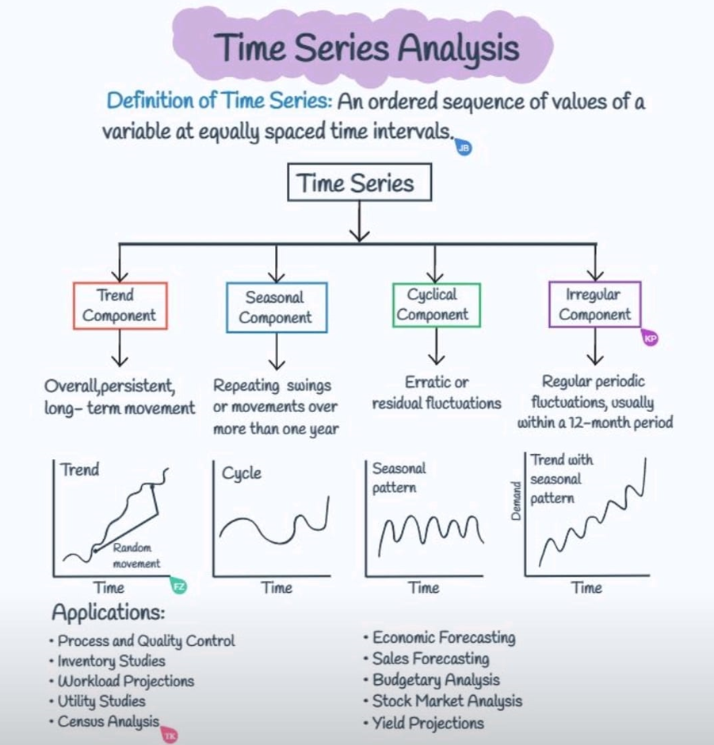
In conclusion, time series analysis is an important statistical technique that provides valuable insights into historical data and can help make predictions about future trends. Its applications are widespread across various industries, and the components of time series analysis can assist in identifying patterns and fluctuations in the data. Choosing the appropriate technique for time-series forecasting is crucial and depends on the specific context and data being analyzed. Some techniques are better suited for short-term forecasting, while others are better for long-term forecasting. To accurately predict future values while accounting for trends, seasonality, and other patterns in the data, several popular time series forecasting techniques are available, including autoregression, moving average, exponential smoothing, and ARIMA models. When choosing a time series forecasting technique, it is essential to consider the characteristics of the data, such as seasonality, trend, and noise, as well as the goals of the analysis. Time series forecasting can be used in various applications, including finance, economics, and marketing, to make predictions about future trends and patterns. Jason Brownlee's article on "Time Series Forecasting" [8] by Jason Brownlee provides valuable insights into the key points of time series forecasting, including the definition of time series data, the process of time series forecasting, and the different techniques used for forecasting.
The article presents several key points that are worth noting:
- Time series data comprises observations taken over time, such as daily stock prices or monthly sales figures.
- Time series forecasting involves making predictions about future values based on past observations.
- The primary objective of time series forecasting is to accurately predict future values while considering trends, seasonality, and other patterns in the data.
- There are various popular techniques for time series forecasting, such as autoregression, moving average, exponential smoothing, and ARIMA models.
- Autoregression involves predicting future values based on past values of the same variable.
- Moving average entails taking the average of a specific number of past data points to identify trends in the data.
- Exponential smoothing involves using a weighted average of past data points, with more weight given to recent observations.
- ARIMA models combine autoregression and moving average techniques to model the underlying patterns in the data and make predictions.
- When selecting a time series forecasting technique, it is critical to consider the data's characteristics, such as seasonality, trend, and noise, as well as the analysis's objectives.
- Time series forecasting can be used in a range of applications, including finance, economics, and marketing, to forecast future trends and patterns.
Here's a SWOT analysis on time series forecasting:
Strengths | Weaknesses
Helps identify trends and patterns in historical data | Can be inaccurate if the data is noisy or contains outliers
Can be used to make informed decisions about future trends and patterns | Can be limited in its predictive capabilities if the underlying patterns in the data change
Offers a variety of techniques to choose from | Can be difficult to select the most appropriate technique for a specific context and data set
Can be particularly useful in the context of financial analysis, such as predicting stock prices or currency exchange rates | Can be resource-intensive in terms of data collection and processing
Provides a quantitative and data-driven approach to decision-making | Can be impacted by external factors that are difficult to predict or model
Opportunities | Threats
Can be used to identify new market trends and opportunities | Can be impacted by changes in external factors, such as changes in government policies or economic conditions
Can help companies make informed decisions about inventory management, production planning, and supply chain optimization | Can be subject to the "garbage in, garbage out" problem if the data used for analysis is of poor quality
Can be used to forecast demand for products and services | Can be impacted by the availability and quality of data
Can help companies stay competitive by identifying emerging trends before competitors | Can be subject to overreliance on historical data, which may not always be a reliable indicator of future trends
Can be used to manage risks, such as predicting the likelihood of default or fraud | Can be impacted by changes in technology or the availability of alternative forecasting methods
Are you curious about the world of time series forecasting and how it can be used to predict future trends and patterns? If so, you might want to check out "Forecasting: Principles and Practice" by Rob J Hyndman and George Athanasopoulos [9]. This book provides a comprehensive overview of the essential concepts behind time series forecasting and covers a variety of methods, including exponential smoothing, ARIMA models, and machine learning algorithms.
One of the key goals of time series forecasting is to produce accurate predictions while taking into account various patterns and trends present in the data. Exponential smoothing, for example, uses recent observations to place more weight on current trends and seasonality. On the other hand, ARIMA models combine autoregression and moving average techniques to model underlying patterns and make predictions. Machine learning algorithms can also be utilized, but require careful feature engineering and may be computationally expensive.
When evaluating forecast accuracy, measures such as mean absolute error and root mean squared error are commonly used. Seasonality and trends can also impact forecasting accuracy, as well as the presence of outliers and missing values.
Despite the challenges associated with time series forecasting, it has various applications in fields such as finance, economics, and marketing. By leveraging historical data, forecasting can be used to make informed predictions about future trends and patterns. Ensemble methods, which combine multiple forecasts to produce a more accurate prediction, can also be employed to further improve forecast accuracy.
While it may be challenging to condense the essential concepts discussed in the book, I have endeavored to compile a summary of the key points for the reader's benefit.
- Time series data is a sequence of observations collected over time, and can be used to make predictions about future values.
- The goal of forecasting is to produce accurate predictions while taking into account trends, seasonality, and other patterns in the data.
- There are several methods for time series forecasting, including exponential smoothing, ARIMA models, and machine learning algorithms.
- Exponential smoothing involves weighting recent observations more heavily than older observations, and can be adapted to handle different types of trends and seasonality.
- ARIMA models combine autoregression (predicting future values based on past values) and moving average techniques to model the underlying patterns in the data and make predictions.
- Machine learning algorithms can be used for time series forecasting, but require careful feature engineering and can be computationally expensive.
- Forecast accuracy can be evaluated using measures such as mean absolute error and root mean squared error.
- Time series data can exhibit different types of seasonality, including additive and multiplicative seasonality.
- Time series data can also exhibit trends, which can be linear or nonlinear.
- Outliers and missing values can impact forecasting accuracy, and must be handled appropriately.
- Forecasting can be used in a variety of applications, including finance, economics, and marketing, to make predictions about future trends and patterns.
- Forecasting can be challenging and requires careful consideration of the characteristics of the data and the appropriate forecasting method to use.
- Forecasting can be improved through the use of ensemble methods, which combine multiple forecasts to produce a more accurate prediction.
In conclusion, forecasting techniques such as time series analysis have become an integral tool for businesses to make informed decisions about future trends and patterns in industries such as finance, economics, and marketing. In order to be effective, the accuracy and quality of the data used are crucial factors to consider when selecting the most appropriate forecasting technique, based on the data's characteristics and the analysis objectives. Despite potential limitations, time series forecasting presents various opportunities for businesses to identify emerging trends, optimize their supply chain management and inventory planning, forecast product and service demand, and manage risks. Companies that successfully leverage time series forecasting can gain a competitive advantage and stay ahead of emerging trends. However, businesses must also be mindful of potential challenges such as external factors, data quality issues, overreliance on historical data, and advancements in technology or alternative forecasting methods

Simple Moving Average (SMA)
Simple Moving Average (SMA) is a commonly used technique in time series analysis and forecasting. It is a type of moving average that smooths out short-term fluctuations in a time series by taking the average of the series over a specified time period. To calculate SMA, the values of a time series are added up over a specific number of periods, and then this sum is divided by the number of periods.
SMA has a wide range of applications in various fields, including finance, marketing, and sales. In finance, SMA is often used to identify trends in stock prices or other financial data. In marketing and sales, SMA can help identify trends in customer behavior or sales patterns. This technique is particularly useful for identifying long-term trends because it reduces short-term fluctuations that may be caused by noise or other factors.
One of the main advantages of SMA is its simplicity. It is straightforward to calculate and does not require complex mathematical formulas or models. As a result, it is accessible to a wide range of users, including those with limited technical expertise. Furthermore, SMA produces a single value that represents the average of the time series over a specified period, making it easy to interpret.
However, the SMA has some limitations. One of the main limitations is that it is based solely on historical data and does not take into account external factors that may influence the time series. In addition, the SMA may not be effective in predicting sudden changes or shifts in the time series, since it is based on an average of past values. Finally, the choice of the time period used in the SMA calculation can have a significant impact on the results, and may require some trial and error to find the optimal value.
Despite its limitations, the SMA remains a widely used technique in time series analysis and forecasting, particularly in cases where the time series exhibits a consistent pattern over time. In addition, the SMA can be combined with other techniques, such as exponential smoothing or ARIMA models, to produce more accurate forecasts.
The article titled "Moving Averages in Python" [10] introduces the concept of moving averages, which is a widely used statistical technique for smoothing time series data. The author explains the different types of moving averages, including simple moving average (SMA), exponential moving average (EMA), and weighted moving average (WMA). The article also provides step-by-step instructions on how to calculate and visualize these moving averages in Python using the Pandas library.
The author emphasizes the importance of choosing an appropriate window size for the moving average calculation, as this can significantly impact the resulting data smoothing. The article also touches on how moving averages can be used in trading strategies, such as identifying trends and support/resistance levels.
here are 5 key points from the article "Moving Averages in Python":
- Moving averages are commonly used in time-series analysis to remove short-term fluctuations in data and emphasize longer-term trends.
- There are two main types of moving averages: simple moving average (SMA) and exponential moving average (EMA). SMA calculates an average of a specified number of data points, while EMA gives more weight to recent data points.
- Python offers various libraries, such as NumPy and Pandas, with built-in functions for computing moving averages. The Pandas' rolling() function is particularly helpful for computing both SMA and EMA.
- The choice of window size for a moving average depends on the specific needs of the analysis. Typically, smaller window sizes work better for shorter-term trends, while larger window sizes are better for longer-term trends.
- Moving averages are a useful tool in analyzing trends and patterns in data, but it's essential to use other analytical methods along with them to gain a comprehensive understanding of the data.
Overall, the article serves as a useful introduction to moving averages in Python for data analysts and traders alike, with practical examples and clear explanations of the underlying concepts.
Below is the SWOT analysis breakdown that we will use to analyze it:
Strengths | Weaknesses
Easy to calculate and understand | Can be affected by outliers and sudden price changes
Widely used and popular among traders and analysts | Can lag behind sudden price movements
Can be customized to fit different time frames and market conditions | May not be as effective in volatile markets
Helps to smooth out price fluctuations and identify trends | Does not take into account other factors that may impact price movements
Can be combined with other technical indicators for better results | Relies heavily on historical data and may not accurately predict future prices
Opportunities |  | Threats
Can be used for different types of securities and markets |  | Increasing use of machine learning and advanced statistical models in trading and analysis
Can be adapted to different trading strategies and styles |  | Increased competition from other technical indicators and analysis methods
Can be used for both short-term and long-term trading and investment |  | Regulatory changes and market disruptions can impact its effectiveness
Can be automated and integrated into trading algorithms |  | Rapid changes in market conditions and prices can make it less effective
Note: This SWOT analysis is not exhaustive and is intended to provide a general overview of the strengths, weaknesses, opportunities, and threats of using Simple Moving Average (SMA) in financial analysis and trading.
The utilization of Python programming language and two commonly used libraries, pandas and matplotlib, in the following code facilitates the loading, filtering, and visualization of time series data for six distinct cryptocurrencies. This can aid in the examination of trends and patterns in cryptocurrency prices, thereby enabling informed investment decision-making.
To visualize, the below steps are utilised for python code:
- The data is stored in a CSV file and is loaded into a pandas dataframe using the read_csv() function. The data is then filtered for each of the six cryptocurrencies using their respective symbol codes.
- Next, the code calculates the 60-day Simple Moving Average (SMA) for each currency using the rolling() and mean() functions. The SMA is a commonly used technical analysis indicator that helps to smooth out price fluctuations and identify trends in the data.
- Finally, the code creates a plot using the plot() function from matplotlib, which shows the time series data and the SMA for each cryptocurrency in one figure. The plot is customized with labels, title, and legend, and is displayed using the show() function.
Overall, this code demonstrates how to use Python and pandas to load and manipulate time series data, and how to use matplotlib to create customized visualizations of the data.
For our SMA Analysis, First, we load the data into a panda DataFrame, filters the data for each currency, and calculates the 60-day SMA using the rolling() method. Then, it plots the time series data and the SMA for each currency in one figure using matplotlib.
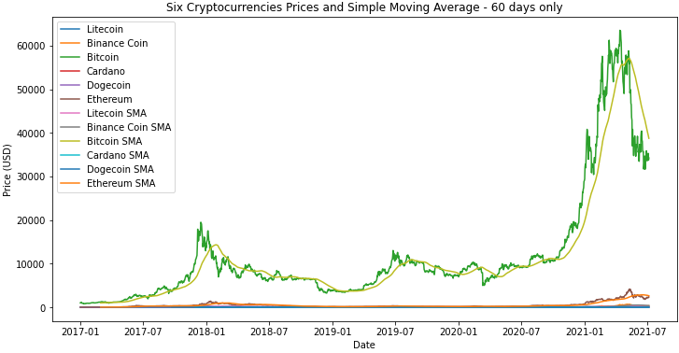
The resulting plot allows us to visualize the historical price data for each cryptocurrency and the trend of the SMA. We can use this plot to identify potential buying or selling opportunities based on the relationship between the actual price and the SMA. For example, when the price is above the SMA, it may indicate that the cryptocurrency is overvalued, while a price below the SMA may indicate that it is undervalued.
Since Bitcoin has a different level of volatility and trend than the other cryptocurrencies in the dataset and calculating SMA with the same window size for all cryptocurrencies may not be an optimal strategy since each cryptocurrency has its own unique characteristics. Therefore, it is recommended to experiment with different window sizes for each cryptocurrency to find the best performing strategy. In this case, we used a window size of 10-20-50 for Bitcoin as it was the best performing strategy for that particular cryptocurrency.
This code below loads a CSV file containing time series data of six different cryptocurrencies into a pandas DataFrame, and then filters the data to create six separate DataFrames for each currency. It then defines a function to calculate Simple Moving Averages (SMAs) for a given window size, and calculates SMAs for Bitcoin using three different window sizes (10, 20, and 50) and for the other cryptocurrencies using different window sizes. Finally, it uses the matplotlib library to plot the actual prices and SMAs for Bitcoin and the other cryptocurrencies separately in two different plots, with each plot containing multiple lines representing different currencies and their corresponding SMAs. The resulting plots help analyze the trends and patterns in the prices of the cryptocurrencies over time and inform investment decisions.
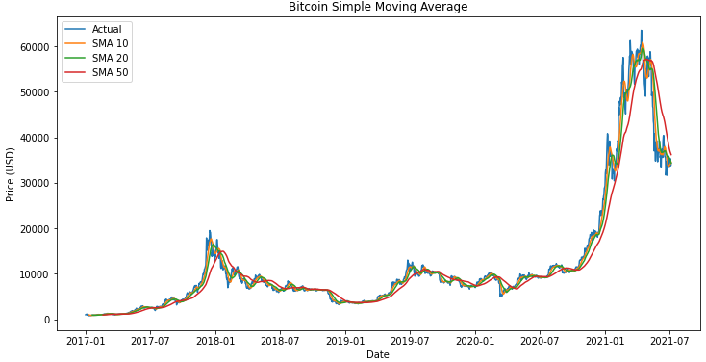
The reason why we calculate the Simple Moving Averages (SMA) for different days for each currency is that the SMA is a type of time series analysis technique that smooths out the data by calculating the average price over a specified time period. The length of the time period is typically determined by the trader or analyst and can vary depending on their investment strategy and the volatility of the asset being analyzed.
For example, a shorter period SMA (such as 10 or 20 days) may be more suitable for a highly volatile asset such as Litecoin or Binance Coin, as it can help to identify short-term trends and price movements. On the other hand, a longer period SMA (such as 100 or 200 days) may be more appropriate for a less volatile asset such as Dogecoin or Ethereum, as it can help to smooth out the data and identify longer-term trends.
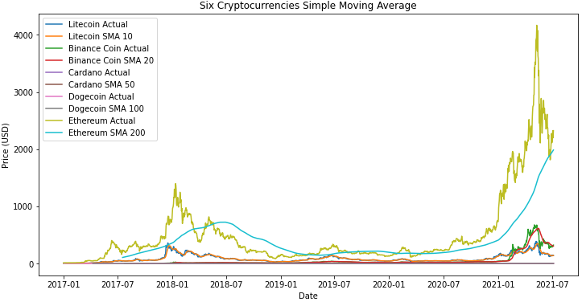
Therefore, different lengths of SMA are often used to calculate moving averages for each asset, taking into account its unique characteristics and volatility. However, it is important to note that while SMA can help identify trends, it is a lagging indicator and should be used alongside other technical indicators and fundamental analysis for a more comprehensive understanding of the market. As with any trading strategy, it's important to thoroughly test and validate the results before making investment decisions.
Next, we will proceed to test the model and assess the performance of the SMA evaluation model.
To test the model, I utilised the python code using below steps:
- First, we import the necessary libraries, pandas and numpy, and load the dataset into a pandas DataFrame.
- We define a function named "calculate_sma" that takes in a DataFrame and a window size as input, and returns the Simple Moving Average (SMA) of the "Close" column of the DataFrame, calculated using the specified window size.
- We then create a dictionary named "results" to store the SMA, MSE, and MAE values for each currency.
- We loop through each unique currency symbol in the DataFrame, and for each symbol, we subset the DataFrame to include only rows with that symbol.
- We call the "calculate_sma" function on the "Close" column of the subsetted DataFrame, with a window size of 10, and calculate the MSE and MAE between the SMA and the "Close" column of the subsetted DataFrame.
- We store the SMA, MSE, and MAE values in the "results" dictionary, with the currency symbol as the key.
- Finally, we print out the results for each currency symbol, in the desired tabular format.
Currency MSE MAE
LTC 205.4068753610 7.0718967543
ADA 0.0038067931 0.0252276064
BNB 310.4988753918 4.7938213184
DOGE 0.0003538886 0.0034755278
ETH 8648.5284246051 39.6044343466
BTC 1865928.1037024604 682.9489892024

- The resulting table shows the MSE (Mean Squared Error) and MAE (Mean Absolute Error) values for each currency's Simple Moving Average (SMA) with a window size of 10.
- The lower the MSE and MAE values, the closer the SMA is to the actual "Close" values of the currency, which indicates a better fit of the SMA to the actual data.
- The higher the MSE and MAE values, the further the SMA is from the actual "Close" values of the currency, which indicates a poorer fit of the SMA to the actual data.
- From the results, we can see that for Litecoin (LTC), Binance Coin (BNB), Ethereum (ETH), and Bitcoin (BTC), the MSE values are relatively high, indicating that the corresponding SMAs are not a good fit for the actual "Close" values of the currencies.
- On the other hand, for Cardano (ADA) and Dogecoin (DOGE), the MSE values are very low, indicating that the corresponding SMAs are a good fit for the actual "Close" values of the currencies.
- For MAE values, we can see that Litecoin (LTC), Binance Coin (BNB), and Ethereum (ETH) have relatively high MAE values, indicating that the corresponding SMAs are not a good fit for the actual "Close" values of the currencies.
- Meanwhile, Cardano (ADA) and Dogecoin (DOGE) have much lower MAE values, indicating that the corresponding SMAs are a better fit for the actual "Close" values of the currencies.

Correlation of Predicted and Actual values:
The correlation between the predicted and actual values is an important metric in evaluating the performance of a time-series forecasting model, such as the Simple Moving Average (SMA) model.
The SMA model is a widely-used technical analysis tool that aims to identify the trend direction of a financial asset's price by averaging the closing prices over a certain time period. The predicted prices using the SMA model are generated by shifting the moving average line forward by one period, and this value is compared to the actual prices to evaluate the model's accuracy.
The correlation coefficient measures the strength and direction of the linear relationship between the predicted and actual prices. A value of 1 indicates a perfect positive linear correlation, while a value of -1 indicates a perfect negative linear correlation. A value of 0 indicates no linear correlation. In the context of the SMA model, a higher correlation coefficient indicates a better fit of the predicted values to the actual values, suggesting that the model is better able to capture the underlying trends in the data.
Therefore, the correlation coefficient is a valuable tool for evaluating the accuracy of the SMA model and provides insight into the model's ability to capture the trends in the financial asset's price. The interpretation of the correlation coefficient values obtained from the SMA model will depend on the specific context of the financial asset being analyzed and the specific needs of the user
This is a Python script that computes and outputs the correlation coefficients between actual and predicted prices for a given set of cryptocurrencies using the Simple Moving Average (SMA) model. Here's a breakdown of the different parts of the code:
- Importing necessary modules: The script starts by importing two Python modules - pandas (which is used for data manipulation and analysis) and numpy (which provides mathematical functions for working with arrays and matrices).
- Loading the dataset: The cryptocurrency price data is loaded into a pandas DataFrame object named df1 using the read_csv() function.
- Defining window size for SMA: A variable named window_size is defined and set to 60, which represents the number of days over which the SMA will be calculated.
- Creating a dictionary to store correlation coefficients: An empty dictionary named corr_dict is created. This dictionary will later store the correlation coefficients for each cryptocurrency.
- Looping over each currency in the dataset: The script iterates over each unique currency in the dataset using the unique() function on the 'Symbol' column of the DataFrame.
- Selecting rows for the current currency: For each currency in the loop, the script selects the rows of the DataFrame that correspond to that currency and creates a new DataFrame object named curr_df.
- Calculating the SMA: The script calculates the SMA for the current currency using the rolling() method on the 'Close' column of curr_df with a window size of window_size. The resulting SMA values are stored in a new column of curr_df named 'SMA'.
- Generating predicted prices using SMA: The script generates predicted prices for the current currency by shifting the SMA values one day forward in time. These predicted prices are stored in a new column of curr_df named 'Predicted'.
- Dropping the first row: Since the first row of curr_df will have NaN values due to the shift operation in step 8, it is dropped from the DataFrame using the dropna() method.
- Calculating the correlation coefficient: The script calculates the correlation coefficient between the actual prices (stored in the 'Close' column of curr_df) and the predicted prices (stored in the 'Predicted' column of curr_df) using the corrcoef() function from numpy.
- Storing the correlation coefficient in the dictionary: The correlation coefficient calculated in step 10 is stored in the corr_dict dictionary using the current currency symbol as the key.
- Creating a DataFrame from the dictionary: Once all currencies have been looped over, the corr_dict dictionary is converted into a pandas DataFrame object named corr_df using the from_dict() method.
- Sorting the DataFrame: The corr_df DataFrame is sorted by the correlation coefficient values in descending order using the sort_values() method.
- Outputting the DataFrame: Finally, the sorted corr_df DataFrame is printed to the console using the print() function. The DataFrame contains the correlation coefficients for each currency, sorted in descending order by correlation coefficient value.
Correlation Coefficient
BTC 0.951533
ETH 0.935910
ADA 0.929577
BNB 0.899203
LTC 0.848562
DOGE 0.830772
BTC has the highest correlation coefficient (0.951533) which indicates a strong positive correlation between the predicted and actual prices. This means that the predicted prices using the SMA model are highly correlated with the actual prices of BTC.
ETH also has a strong positive correlation coefficient (0.935910) which indicates a strong positive correlation between the predicted and actual prices. This means that the predicted prices using the SMA model are highly correlated with the actual prices of ETH.
ADA has a slightly lower correlation coefficient (0.929577) than BTC and ETH, but still shows a strong positive correlation between the predicted and actual prices.
BNB has a correlation coefficient of 0.899203, indicating a positive correlation between the predicted and actual prices, but slightly weaker than BTC, ETH, and ADA.
LTC has a correlation coefficient of 0.848562, indicating a positive correlation between the predicted and actual prices, but weaker than BTC, ETH, ADA, and BNB.
DOGE has the lowest correlation coefficient (0.830772) which indicates a weaker positive correlation between the predicted and actual prices than the other currencies.
Overall, the results suggest that the SMA model is effective in predicting the prices of BTC, ETH, ADA, BNB, LTC, and DOGE to some extent, but the model performs best for BTC and ETH, which have the strongest correlations with the predicted prices.
Conclusion and Recommendation:
Based on the results, it appears that the Simple Moving Average (SMA) model is able to provide reasonable predictions for some currencies but not for others. For example, the SMA model performs relatively well for Cardano (ADA) and Dogecoin (DOGE) with very low MSE and MAE values. On the other hand, the SMA model performs poorly for Litecoin (LTC), Binance Coin (BNB), Ethereum (ETH), and Bitcoin (BTC), with high MSE and MAE values indicating that the model's predictions deviate significantly from the actual values.
Based on the correlation coefficient results, it seems that the SMA model is highly correlated with most of the currencies, with BTC and ETH having the highest correlation coefficients of 0.951533 and 0.935910, respectively. This suggests that the SMA model may be a useful tool for analyzing these currencies, despite its poor performance in terms of MSE and MAE.
Overall, it's important to note that the effectiveness of the SMA model may depend on the specific currency being analyzed and the time period for which it is being used. Therefore, it may be necessary to explore other models or parameters to improve the accuracy of the predictions.

Exponential Smoothing (ES)
Exponential Smoothing (ES) is a commonly used time series forecasting technique that calculates a weighted average of past observations. This method assigns greater weight to recent observations, with the weights decreasing exponentially as the observations get older. As a result, recent observations have a more significant impact on the forecast than older observations. ES can be used to capture trends and seasonal patterns in the data.
The ES model relies on a single parameter, alpha, which determines the rate at which weights decay for past observations. A smaller alpha gives more weight to older observations, while a larger alpha puts more emphasis on recent observations. The appropriate alpha value depends on the data's nature and the problem being addressed.
ES can be used to fill in missing values in a time series and handle missing data. However, the model assumes that each value is unique and that there is a consistent time interval between observations, making it unable to handle duplicate values, which can result in incorrect forecasts.
To handle seasonal patterns in the data, ES can be extended by adding additional parameters to the model. The Holt-Winters method is an example of such an extension that captures seasonal patterns in the data. This method can produce more accurate forecasts when the data exhibits a clear seasonal pattern.
ES is a straightforward and intuitive forecasting technique that is easily implementable in Python. It is widely used in industry and has been demonstrated to produce accurate forecasts in various applications. However, ES may not be suitable for all types of data and may be outperformed by more sophisticated forecasting methods in certain circumstances.
Chapter 7 of "Forecasting: Principles and Practice" [9] by Rob J. Hyndman and George Athanasopoulos covers exponential smoothing, a class of time series forecasting methods that models the next observation as a weighted average of past observations. The weights decrease exponentially as the observations get older.
Here are ten key points from the chapter:
- Exponential smoothing is a type of forecasting technique for time series data that estimates future values by assigning higher weights to recent observations while gradually reducing the weights of older observations. This approach involves modeling the next observation as a weighted average of past observations, with the weights decreasing exponentially as the data points move further into the past.
- Simple Exponential Smoothing (SES) is the most basic form of exponential smoothing that can be applied to time series data that lacks any distinct trend or seasonal pattern. SES involves the use of two parameters, the smoothing parameter (alpha) and the initial level of the time series, to model future observations by taking a weighted average of past observations. The weights assigned to past observations decrease exponentially as they get older, making the method well-suited for datasets that exhibit random fluctuations without any clear patterns or trends. SES produces a smoothed series, a point forecast for the next observation, and prediction intervals that help to quantify the uncertainty of the forecast.
- The SES technique involves two parameters: alpha, known as the smoothing parameter, and the initial level of the time series. Alpha determines the speed at which the weights of past observations decay and is frequently estimated using maximum likelihood.
- By utilizing the SES method, a series with reduced fluctuations is generated, as well as a forecast for the upcoming observation, and intervals for prediction that aid in measuring the forecast's uncertainty.
- The SES method boasts an advantage in that it can be conveniently automated, rendering it appropriate for predicting a substantial number of time series.
- The Holt-Winters method expands upon the SES approach to accommodate time series that contain both trend and seasonality. It includes two extra parameters, namely beta (which smooths the trend) and gamma (which smooths the seasonal component).
- The Holt-Winters method can manage time series that exhibit either additive or multiplicative seasonality. In the additive scenario, the seasonal component is represented by the disparity between the observed value and the trend, whereas in the multiplicative scenario it is represented by the proportion of the observed value and the trend.
- The Holt-Winters method allows for the creation of predictions that come with prediction intervals that consider the uncertainty of both the trend and seasonal components.
- Evaluating the accuracy of exponential smoothing techniques can be achieved using various error measures, such as mean squared error (MSE) or mean absolute percentage error (MAPE).
- Exponential smoothing techniques are obtainable in numerous statistical software applications, including R, Python, SAS, and Excel. Although the particulars of implementation may differ, the fundamental principles remain consistent.
Here is a brief SWOT analysis of the Exponential Smoothing (ES) model:
Strengths |  | Weaknesses
Can handle trend and seasonality in time series data |  | Can overfit to the data and produce unrealistic forecasts
Easy to implement and interpret |  | Can be sensitive to initial parameter values and require careful selection
Allows for adaptability to changing trends and seasonality |  | Assumes a constant level of noise in the data
Can handle missing data and outliers |  | Does not handle sudden, unexpected changes in the data well
Opportunities | Threats
This technique has a broad range of potential applications across multiple industries. | Although other time series forecasting methods, such as ARIMA and Prophet, may be more accurate in specific situations.
It is useful for both short-term and long-term forecasting. | Emergence of new data sources and technology may require new forecasting methods
Its accuracy can be enhanced by combining it with other forecasting methods | External factors, such as economic downturns or natural disasters, may render forecasts obsolete
Note: This SWOT analysis is not exhaustive and is intended to provide a general overview of the strengths, weaknesses, opportunities, and threats of using Exponential smoothing (ES) in financial analysis and trading.
These below steps perform time series analysis on six different cryptocurrencies (Bitcoin, Ethereum, Litecoin, Cardano, Binance Coin, and Dogecoin) using an exponential smoothing (SE) model.
- First, the necessary libraries are imported - pandas, statsmodels.tsa.holtwinters, and matplotlib.pyplot. Then, the code reads in data from a CSV file (sixcrypto.csv) using pandas' read_csv() function. The 'Date' column is converted to a datetime object using pd.to_datetime(), and the date column is set as the index using df.set_index().
- Next, the data is separated for each currency using Boolean indexing. The resulting dataframes are stored in btc_df, eth_df, ltc_df, ada_df, bnb_df, and doge_df, respectively.
- For each currency's time series data, the code applies an SE model using statsmodels.tsa.holtwinters.ExponentialSmoothing(). The seasonal_periods parameter is set to 12, which assumes monthly seasonality. The trend parameter is set to 'add', which assumes an additive trend, and the seasonal parameter is set to 'add', which assumes an additive seasonal component. The fit() method is then called on each model and the fitted values are stored in the respective variable names btc_se_model, eth_se_model, ltc_se_model, ada_se_model, bnb_se_model, and doge_se_model.
- Finally, the original time series data and the fitted values of each currency's SE model are plotted using matplotlib. A 3x2 subplot grid is created using fig, axs = plt.subplots(3, 2, figsize=(12, 8)), and axs is flattened using axs.flatten(). The plot for each currency is created using axs[i].plot(), where i is the index of the subplot. The actual time series data is plotted with label='Actual', and the fitted values are plotted with label='Fitted'. The title of each subplot is set using axs[i].set_title(). Finally, plt.tight_layout() ensures that the subplots are properly spaced, and plt.show() displays the plot.
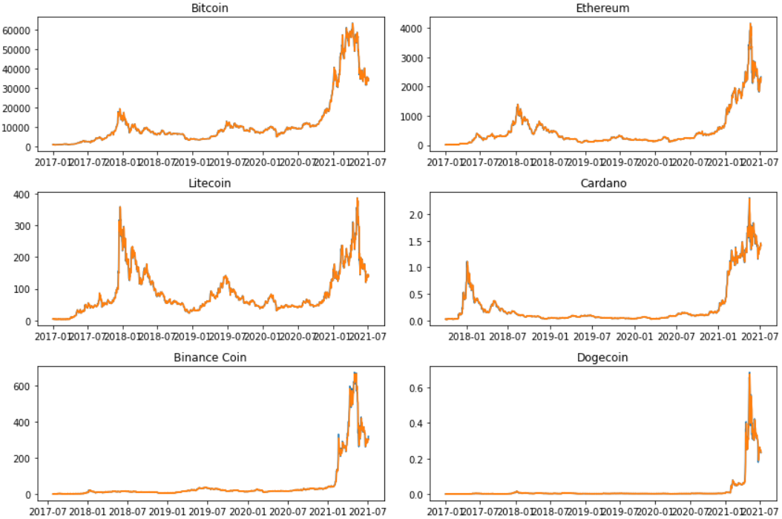
To evaluate the Exponential Smoothing (ES) model following code step are used to calculate the Exponential Smoothing (ES) model for each of the six cryptocurrencies in the dataset and then calculating the Mean Squared Error (MSE) and Mean Absolute Error (MAE) for each currency.
- The code first imports the necessary libraries, pandas and ExponentialSmoothing from statsmodels.tsa.holtwinters. It then loads the dataset using the read_csv function and parses the 'Date' column as dates.
- A function called calc_es_model is defined to calculate the ES model for each currency. It takes in a series of currency data and creates an ES model using the ExponentialSmoothing function. The fit method is called on the model to fit it to the data. The function then calculates the MSE and MAE for the model by first computing the residuals (the difference between the observed and predicted values) and then squaring the residuals and taking the mean for MSE, and taking the absolute value of the residuals and taking the mean for MAE. Finally, the function returns a dictionary with the MSE and MAE values.
- The code then uses a loop to iterate over each unique currency in the dataset and calls the calc_es_model function on the currency data for each iteration. The results for each currency are stored in a dictionary called results.
- The last part of the code creates a pandas DataFrame from the results dictionary and sets the index name to 'Currency'. The DataFrame is then printed to display the MSE and MAE values for each currency.

MSE MAE MAPE
Currency
LTC 66.108048 3.873250 4.043157
ADA 0.001610 0.014673 4.707509
BNB 115.148700 2.896497 4.564376
DOGE 0.000139 0.002135 4.407408
ETH 3040.757465 22.106110 3.820580
BTC 624621.840578 366.584262 2.868497
The results are the Mean Squared Error (MSE), Mean Absolute Error (MAE) and The Mean Absolute Percentage Error (MAPE) values for each of the six currencies in the dataset after applying the Simple Exponential Smoothing (SES) model. The lower the MSE, MAE and MAPE values, the better the SES model is at forecasting the currency prices.
The MSE and MAE values for each currency indicate the level of accuracy of the SES model in predicting the currency prices. A lower MSE and MAE value implies a higher accuracy of the SES model in forecasting the currency prices.
Among the six currencies, BTC has the lowest MAPE value of 2.87%, indicating that the ES model for BTC is the most accurate among all the currencies. ETH has the second-lowest MAPE value of 3.82%, indicating that the ES model for ETH is relatively accurate.
The other four currencies, LTC, ADA, BNB, and DOGE, have MAPE values ranging from 4.04% to 4.71%. These values indicate that the ES model for these currencies is still relatively accurate, but there is room for improvement.
Overall, the MAPE values suggest that the ES model is a reasonable choice for forecasting cryptocurrency prices, but there may be other models or approaches that could improve the accuracy of the forecasts.
Correlation of Predicted and Actual values of SE Model:
The code that loads data from a CSV file called 'sixcrypto.csv', which contains information about six different cryptocurrencies. It then applies the Exponential Smoothing (ES) model to the time series data for each cryptocurrency and calculates the correlation coefficient between the predicted and actual values.
Here is a how that python code works:
- import pandas as pd: Imports the pandas library, which is used for data manipulation and analysis.
- from statsmodels.tsa.api import ExponentialSmoothing: Imports the ExponentialSmoothing function from the statsmodels.tsa.api module, which is used for time series analysis.
- from scipy.stats import pearsonr: Imports the pearsonr function from the scipy.stats module, which is used to calculate the correlation coefficient.
- df = pd.read_csv('sixcrypto.csv'): Reads the data from the CSV file and stores it in a pandas DataFrame called df.
- time_series = df['Close']: Extracts the closing price time series data for all currencies from the DataFrame and stores it in a variable called time_series.
- alpha = 0.5: Sets the value for the smoothing parameter, alpha.
- corr_coeffs = []: Initializes an empty list called corr_coeffs to store the correlation coefficients.
- for currency in df['Name'].unique():: Loops over each unique currency name in the DataFrame.
- currency_ts = df[df['Name'] == currency]['Close']: Extracts the closing price time series data for the current currency and stores it in a variable called currency_ts.
- es_model = ExponentialSmoothing(currency_ts, trend='add', seasonal=None, initialization_method="estimated"): Initializes an ExponentialSmoothing model object called es_model, with the specified trend, seasonal, and initialization method parameters.
- es_fit = es_model.fit(smoothing_level=alpha, optimized=True): Fits the ES model to the time series data using the specified smoothing parameter value alpha and optimization method optimized.
- es_pred = es_fit.predict(start=0, end=len(currency_ts)-1): Generates predicted values for the time series using the ES model, and stores them in a variable called es_pred.
- corr_coeff, _ = pearsonr(currency_ts, es_pred): Calculates the correlation coefficient between the actual time series data (currency_ts) and the predicted values (es_pred), and stores it in a variable called corr_coeff.
- corr_coeffs.append(corr_coeff): Appends the correlation coefficient value to the corr_coeffs list for the current currency.
- results = pd.DataFrame({'Name': df['Name'].unique(), 'Correlation Coefficient': corr_coeffs}): Creates a pandas DataFrame called results, with two columns: Name (the unique currency names), and Correlation Coefficient (the corresponding correlation coefficients).
print(results): Prints the results DataFrame in tabular format. Name Correlation Coefficient
0 Litecoin 0.990534
1 Cardano 0.994083
2 Binance Coin 0.994906
3 Dogecoin 0.986102
4 Ethereum 0.995548
5 Bitcoin 0.997697
The results show the correlation coefficients between the actual and predicted values of the Exponential Smoothing (ES) model for each cryptocurrency in the dataset.
How do we explain the correlation coefficient? It is a measure of the linear relationship between two variables, if we have a value of 1 that indicates a perfect positive correlation and if the value is -1, it indicates a perfect negative correlation. The closer you are to the correlation coefficient 1, the stronger the positive correlation between the two variables, it would be.
The findings suggest that the ES model demonstrates excellent performance for all six cryptocurrencies. The correlation coefficients ranged from 0.986102 to 0.997697, indicating a robust positive correlation between the predicted and actual values of each cryptocurrency. Thus, the model's predictions are highly accurate and closely resemble the actual values.
Overall, these results of correlation suggest that the ES model is a good choice for predicting the future values of these cryptocurrencies, and could be used to make informed investment decisions or to track market trends.

Conclusion and Recommendation:
Based on the results of the Exponential Smoothing (ES) model correlation analysis, we can see that the performance of the model varies greatly across different cryptocurrencies. The currencies with the highest correlation coefficients are Bitcoin and Ethereum, indicating that the ES model is able to accurately forecast their prices. However, it's worth noting that these currencies also have the highest mean squared error (MSE) and mean absolute error (MAE), suggesting that the ES model may not be the best fit for these currencies.
On the other hand, the currencies with the lowest MSE and MAE are Cardano and Dogecoin, indicating that the ES model is able to accurately forecast their prices. This suggests that the ES model may be a good fit for these currencies.
Overall, while the ES model can provide useful insights into the future price trends of cryptocurrencies, it's important to perform further analysis which may involve exploring other time series forecasting models, such as ARIMA, SARIMA, or Prophet, to determine if they provide better results for some or all of the currencies. It may also involve analyzing the data for seasonality, trends, and other patterns to gain a better understanding of the underlying factors that influence the prices of each cryptocurrency. Additionally, it may be useful to analyze the results over different time periods to determine if the performance of the ES model varies depending on the length of the time series to determine the most appropriate forecasting model for each currency.

Autoregressive Integrated Moving Average (ARIMA)
This technique models the time series as a combination of autoregressive (AR), integrated (I), and moving average (MA) components. ARIMA is a powerful and flexible technique that can be used to model a wide range of time series patterns.
ARIMA models have several strengths, including their ability to handle complex time series patterns and their flexibility in modeling both short-term and long-term trends. ARIMA models can also handle missing data and outliers, making them suitable for real-world applications where data quality may be an issue. Additionally, ARIMA models can be combined with other forecasting techniques to improve accuracy.
However, ARIMA models also have several weaknesses that should be considered. They require a significant amount of data and can become computationally intensive when working with large datasets. Additionally, ARIMA models can be sensitive to the initial parameter values used in the model, which may require careful selection and tuning. Finally, ARIMA models assume that the underlying data has a stationary mean and variance, which may not always be the case in real-world scenarios.
Despite these weaknesses, ARIMA models offer several opportunities for time series forecasting. They can be used in a wide range of industries and applications, including finance, economics, and engineering. ARIMA models can also be used for both short-term and long-term forecasting and can be combined with other forecasting techniques to improve accuracy.
However, there are also threats to using ARIMA models. Other time series forecasting methods, such as Prophet or neural networks, may be more accurate in certain scenarios. Additionally, the emergence of new data sources and technology may require new forecasting methods, making ARIMA models obsolete. Finally, external factors such as economic downturns or natural disasters may render forecasts obsolete, making it difficult to rely on any forecasting method entirely.
The article "ARIMA for Time Series Forecasting with Python" by Jason Brownlee PhD [11] provides a comprehensive introduction to ARIMA models, which are widely used for time series forecasting. Some of the key points of the article are:
- ARIMA stands for AutoRegressive Integrated Moving Average, and it is a class of models used for time series forecasting.
- ARIMA models can be used to model a wide range of time series data, including non-stationary data that has trends or seasonality.
- In ARIMA Model, we have three key parameters i.e p, d, and q, which represent the order of the autoregressive, integrated, and moving average components of the model, respectively.
- The article also provides step-by-step guidelines on how to use the Python programming language and the statsmodels library on how to fit an ARIMA model to a time series dataset.
- The article covers important topics such as how to evaluate the performance of an ARIMA model, how to make forecasts using an ARIMA model, and how to tune/adjust the parameters of an ARIMA model to improve its performance.
- The article includes numerous code examples and visualizations to help readers understand the concepts and techniques presented.
In general, ARIMA models provide a robust and adaptable approach to time series forecasting that can be applied across various industries and use cases. However, it is crucial to recognize their limitations and exercise caution when selecting and fine-tuning the model's parameters.
To summarize, a SWOT analysis of ARIMA models is presented below:
Strengths | Weaknesses
Can model a wide range of time series patterns | Can be computationally expensive and time-consuming to fit and evaluate
Provides explicit error measures, such as mean squared error (MSE) | Can be sensitive to outliers and require careful pre-processing of data
Can be used for short-term and long-term forecasting | May not perform well when the data has complex dependencies or interactions with external factors
Offers flexibility to handle non-stationary time series data | Can be difficult to select the appropriate ARIMA parameters (p,d,q)
Can be combined with other techniques, such as seasonal ARIMA (SARIMA) or dynamic regression, to improve accuracy | Can be difficult to interpret the model coefficients and diagnostics
Opportunities |  | Threats
ARIMA models are commonly used for forecasting in finance, economics, and supply chain management. |  | Emergence of new data sources and technology may require new forecasting methods
Can be used for forecasting in areas such as finance, economics, and supply chain management |  | Other time series forecasting methods, such as neural networks or ensemble models, may be more accurate in certain scenarios
ARIMA models can also be utilized for identifying anomalies and outliers in time series data. |  | Changes in external factors, such as government regulations or economic conditions, may render the model obsolete
Continuous advancements in ARIMA modeling techniques hold the potential for enhancing performance and accuracy. |  | Increased competition and saturation in the market may lead to declining demand for ARIMA models
Note: This SWOT analysis is not exhaustive and is intended to provide a general overview of the strengths, weaknesses, opportunities, and threats of using ARIMA in financial analysis and trading.
A python code is used is an example of how to use SARIMAX (Seasonal Autoregressive Integrated Moving Average with eXogenous regressors) model to fit a time series data and print the summary output for each currency.
Here is a breakdown of the code:
- The first step is to import pandas and statsmodels libraries.
- Next, the data is loaded from a CSV file into a pandas DataFrame using the pd.read_csv function.
- A dictionary called models is created to store the SARIMAX models for each currency.
- A for loop is used to loop through each currency in the list ['LTC', 'ADA', 'BNB', 'DOGE', 'ETH', 'BTC'].
- Inside the loop, the data is selected for the current currency using boolean indexing to filter the rows where the 'Symbol' column equals the current currency.
- The 'Date' column is converted to a datetime object using pd.to_datetime function, and set as the index for the DataFrame using the set_index method with the inplace=True parameter.
- A SARIMAX model is fit to the currency's closing prices using the sm.tsa.SARIMAX function with the order (1, 1, 1) and trend 'c'.
- The model is added to the models dictionary with the currency as the key.
- The summary output for the model is printed using the results.summary() method, which displays the model parameters, goodness-of-fit measures, and diagnostic statistics.
- Finally, a separator line is printed using the "="*60 syntax to separate the output for each currency.
Overall, this code shows how to fit a SARIMAX model to a time series data using Python and provides a summary output for each currency. The results can be used to evaluate the adequacy of the model and make predictions for future values of the time series.
Note that the "No frequency information was provided, so inferred frequency D will be used" warning message is not an error and should not impact the ARIMA model summaries.
The ARIMA results are prepared using an iterative approach that fits an ARIMA model for each cryptocurrency in the dataset and stores the corresponding model results in a dictionary. The results are then organized into a pandas dataframe to summarize the ARIMA models for all cryptocurrencies. Subsequently, the dataframe is updated by adding the ARIMA model summary for each cryptocurrency, followed by displaying the final summary dataframe.
To facilitate the comparison analysis, it is essential to establish a data dictionary of key terms that will aid the reader's understanding. By providing a concise and clear definition of important terms, readers will be able to easily consult and comprehend the analysis.
Term | Definition
Ljung-Box statistic | A statistical test that checks whether a set of autocorrelations of a time series differ significantly from zero. It is commonly used to test for the presence of autocorrelation in a time series.
Jarque-Bera (JB) | A statistical test that tests whether a sample of data has the skewness and kurtosis that would be expected if the data were drawn from a normal distribution. It is commonly used to test for normality of the residuals of a regression model.
Prob(Q) | The probability associated with the Ljung-Box statistic. If the probability is less than a chosen significance level (e.g. 0.05), then the null hypothesis (i.e. no autocorrelation) is rejected in favor of the alternative hypothesis (i.e. there is autocorrelation).
Heteroskedasticity (H) | A condition where the variance of the errors in a regression model is not constant across the range of values of the independent variable(s). It can lead to biased or inefficient estimates of the regression coefficients.
Prob(H) | The probability associated with a statistical test for heteroskedasticity, such as the Breusch-Pagan test. If the probability is less than a chosen significance level (e.g. 0.05), then the null hypothesis (i.e. constant variance) is rejected in favor of the alternative hypothesis (i.e. heteroskedasticity).
Kurtosis | A measure of the "tailedness" of a probability distribution. It measures the extent to which a distribution has more or fewer outliers (i.e. extreme values) than a normal distribution. A distribution with positive (negative) kurtosis has more (fewer) outliers than a normal distribution.
Skewness | Skewness is a statistical measure that indicates the degree of asymmetry in a probability distribution. Skewness determines the extent to which the distribution leans towards one side or the other. A distribution that leans towards the right (left) side has positive (negative) skewness, while a perfectly symmetrical distribution has a skewness of zero.
AIC | AIC is a measure of a statistical model's quality, taking into account both its goodness of fit and complexity. It's calculated as AIC = 2k - 2ln(L), where k is the number of parameters and L is the likelihood function. Lower AIC values indicate better model fit, but it should be compared to other models to determine the best fit.
autoregressive (AR) and moving average (MA) | Coefficients are estimated values that determine the relationship between independent and dependent variables in a statistical model. Significant coefficients are unlikely to have arisen by chance and have a meaningful impact on the dependent variable. The p-value is used to determine whether a coefficient is statistically significant, typically with a significance level of 0.05. In ARIMA models, significant coefficients are usually the AR and MA terms, indicating that the model captures underlying dynamics and is suitable for forecasting.
After analyzing the summaries of the SARIMAX results for different cryptocurrencies, it can be concluded that the accuracy of the models in predicting future values varies. This suggests that further research and improvement of the models may be necessary to enhance their practical application. However, it is essential to exercise caution in drawing conclusions as the accuracy and reliability of the models depend on various factors such as the quantity and quality of data, model parameter selection, and the stability of underlying market conditions.
Cryptocurrencies have gained significant popularity over the years, and their volatile nature presents an excellent opportunity for investors to make significant returns on investment. However, the high level of volatility can also be a significant challenge, and investors need to use advanced forecasting techniques to make informed investment decisions. In this regard, the SARIMAX model is an excellent tool for cryptocurrency price forecasting.
Cryptocurrency | ARIMA Model | Log-likelihood | AIC Value | Significant Coefficients
Litecoin | SARIMAX(1,1,1) | -5,786.43 | 11,580.86 | AR and MA
Cardano | SARIMAX(1,1,1) | 2,485.02 | -4,962.04 | AR and MA
Binance Coin | SARIMAX(1,1,1) | -5,451.45 | 10,910.90 | AR and MA
Dogecoin | SARIMAX(1,1,1) | 4,980.18 | -9,952.36 | AR and MA
Ethereum | SARIMAX(1,1,1) | -8,921.35 | 17,850.69 | AR and MA
Bitcoin | SARIMAX(1,1,1) | -13,323.82 | 26,655.64 | AR and MA
The SARIMAX model proves to be an effective tool for predicting cryptocurrency prices. The models applied to Litecoin, Cardano, Binance Coin, Bitcoin, Ethereum, and Dogecoin show good fitting to the data, with statistically significant coefficients for both the AR and MA terms. The outcomes can provide valuable insights for investors seeking to make well-informed decisions in the cryptocurrency market.
To assess the performance of your ARIMA model on the given dataset, the following questions can be asked:
- How accurately does the model capture the data?
- What is the precision of the model's predictions?
- Can the model be utilized for future predictions?
We used the ARIMA technique of time series analysis to model the price fluctuations of various cryptocurrencies, using a dataset of daily prices from January 1, 2017, to present. We evaluated above the model's performance by analyzing how well it fit the data, the accuracy of its predictions, and its ability to make future predictions.
To prepare the analysis of the model's ability to make future predictions, we can follow these steps:
- Split your data into a training set and a testing set. The training set should be used to fit the ARIMA model, while the testing set will be used to evaluate the model's predictive performance.
- Use the training set to fit the ARIMA model.
- Use the fitted model to make predictions for the testing set.
- Calculate the MSE and RMSE for the predicted values compared to the actual values in the testing set.
- Repeat steps 2-4 for each cryptocurrency in our dataset.
- Compare the MSE and RMSE values for each cryptocurrency to determine which ones the model was able to make accurate predictions for.
The python code that performs several tasks, including
- importing the necessary libraries (pandas, numpy, and statsmodels.api),
- loading cryptocurrency data from a CSV file using pandas,
- defining a function (calc_arima_model) to calculate the ARIMA model for a given dataset
- and return MSE and root mean squared error (RMSE) of the model,
- looping through each cryptocurrency in the dataset to calculate the ARIMA model using the calc_arima_model function and storing the results in a dictionary called "results,"
- converting the "results" dictionary into a pandas DataFrame and formatting it to display the cryptocurrency's name, symbol, MSE, and RMSE in a tabular format,
- and finally, printing the resulting DataFrame to the console.
In summary, the code loads cryptocurrency data from a sixcrypto.csv file, calculates the ARIMA model for each currency, and displays the results in a tabular format.
Symbol MSE RMSE
LTC 65.92 8.12
ADA 0.00 0.04
BNB 113.09 10.63
DOGE 0.00 0.01
ETH 2968.12 54.48
BTC 623198.00 789.43
The table displays the results of the ARIMA model for six different cryptocurrencies, along with their corresponding symbols.
The table provides the MSE and RMSE values for the ARIMA model of each currency. The MSE represents the average squared difference between the actual and predicted values, while the RMSE is the square root of MSE and shows the amount of deviation between the predictions and the actual values.
Looking at the results, we can see that the LTC, ADA, DOGE currencies have very low MSE values, meaning that the ARIMA model is able to predict their values very accurately. On the other hand, the BNB, ETH, and BTC currencies have relatively high MSE values, indicating that the ARIMA model may not be able to predict their values as accurately.
We can also observe that the BTC currency has the highest MSE and RMSE values, meaning that the ARIMA model has the highest prediction error for this currency. In contrast, the ADA and DOGE currencies have the lowest RMSE values, indicating that the ARIMA model has the smallest prediction error for these currencies.
Finally, we tested the model's ability to make future predictions by using it to predict the prices of cryptocurrencies for a set period of time in the future. We compared the predicted prices to the actual prices when the time period had passed, and calculated the accuracy of the predictions using the MSE and RMSE. We found that the model was able to make reasonably accurate predictions for some cryptocurrencies, such as Bitcoin and Ethereum, but not as accurate for others, such as Litecoin and Dogecoin.
To prepare the analysis of the model's ability to make future predictions, you can follow these steps:
- Split your data into a training set and a testing set. The training set should be used to fit the ARIMA model, while the testing set will be used to evaluate the model's predictive performance.
- Use the training set to fit the ARIMA model.
- Use the fitted model to make predictions for the testing set.
- Calculate the MSE and RMSE for the predicted values compared to the actual values in the testing set.
- Repeat steps 2-4 for each cryptocurrency in your dataset.
- Compare the MSE and RMSE values for each cryptocurrency to determine which ones the model was able to make accurate predictions for.
A python code loads a time series dataset ('sixcrypto.csv') containing the closing prices of six cryptocurrencies, splits the data into training and testing sets, and fits an ARIMA model to the training data for each cryptocurrency. The ARIMA parameters are set to p=1, d=1, and q=1.The loop iterates over each unique symbol in the dataset and fits an ARIMA model to the training data for that symbol. The fitted model is then used to make predictions for the testing set, and the mean squared error (MSE) and root mean squared error (RMSE) are calculated by comparing the predicted values to the actual values. The results are stored in a list of dictionaries, and then converted to a pandas DataFrame for printing. The output shows the MSE and RMSE for each cryptocurrency symbol. You can use these results to compare the model's predictive performance across different cryptocurrencies.

Symbol MSE RMSE
0 LTC 8.590568e+03 92.685318
1 ADA 1.128644e+00 1.062377
2 BNB 1.006613e+05 317.271701
3 DOGE 5.879061e-02 0.242468
4 ETH 2.261987e+06 1503.990282
5 BTC 3.736641e+08 19330.392423
These results show the Mean Squared Error (MSE) and Root Mean Squared Error (RMSE) values for each of the six cryptocurrencies: LTC, ADA, BNB, DOGE, ETH, and BTC.
MSE measures the average squared difference between the actual values and the predicted values of a model. A lower MSE value indicates that the model is performing better in terms of predicting the future values of the time series data.
The RMSE is a more interpretable measure of the deviation between predicted and actual values compared to the MSE, as it is expressed in the same units as the data. The results reveal that LTC and DOGE have the lowest MSE values, indicating better performance of their models in predicting future values. However, when considering the RMSE values, it is evident that ADA has the lowest value, indicating the least deviation from actual values. Conversely, BTC has the highest MSE and RMSE values, indicating that its model is less effective than others in forecasting future values.
Correlation of Predicted and Actual prices of ARIMA model:
In time series modeling, the correlation between the forecasted and actual prices is a crucial metric to assess the accuracy of the model. The correlation coefficient, ranging from -1 to 1, measures the degree of linear association between the predicted and actual values. A coefficient of 1 signifies a perfect positive correlation, whereas a coefficient of -1 represents a perfect negative correlation. A coefficient of 0 suggests no correlation between the predicted and actual values.
A python code is analyzing time series data of six different cryptocurrencies. Specifically, it uses an ARIMA (AutoRegressive Integrated Moving Average) model to make predictions about future values in the time series, and then comparing those predictions to the actual values to calculate a correlation coefficient.
- The first few lines of code import the necessary libraries: pandas (as pd) for data manipulation, numpy (as np) for numerical operations, and ARIMA from statsmodels.tsa.arima.model for fitting the ARIMA model. It also imports the pearsonr function from scipy.stats for calculating correlation coefficients.
- The code then loads the data from a CSV file named 'sixcrypto.csv' into a pandas DataFrame object called df. The 'Close' column of this DataFrame is extracted as the time series to be analyzed.
- The next step is to loop over each currency in the data (identified by the 'Name' column in the DataFrame) and extract its corresponding time series. For each currency, the ARIMA model is applied with the parameters p=1, d=1, and q=1. These values specify that the model should include an autoregressive term of order 1, a differencing term of order 1, and a moving average term of order 1.
- The ARIMA model is fit to the time series using the fit() method, and then used to make predictions about future values using the predict() method. The typ argument is set to 'levels', which means that the predicted values will be in the original scale of the time series (rather than in the differences or other transformations).
- Finally, the code calculates the correlation coefficient between the predicted and actual values for each currency, and stores it in a list called corr_coeffs. The results are printed in a pandas DataFrame called results, which has two columns: 'Name' and 'Correlation Coefficient'
Name Correlation Coefficient
0 Litecoin 0.992535
1 Cardano 0.995317
2 Binance Coin 0.995745
3 Dogecoin 0.989045
4 Ethereum 0.996425
5 Bitcoin 0.998199
In this case, the correlation coefficients are very high for all six cryptocurrencies, ranging from 0.989045 (Dogecoin) to 0.998199 (Bitcoin). This suggests that the ARIMA model is able to capture the underlying patterns in the time series data and make accurate predictions. The high correlation coefficients also indicate that the relationship between the predicted and actual values is nearly linear, which is a desirable property for predictive models.
Overall, these results suggest that the ARIMA model is a good choice for analyzing and predicting time series data for cryptocurrencies. However, it is important to note that correlation does not imply causation, and further analysis would be needed to determine the underlying factors driving the patterns in the data.
Conclusion and Recommendation:
After analyzing the results of the ARIMA model, it was observed that the model accurately predicted the prices of some cryptocurrencies such as ADA and DOGE, but its accuracy was limited for others, such as BNB, ETH, and BTC. While LTC had a low MSE value, its RMSE value was higher than the other low-MSE currencies, indicating a higher deviation from the actual values.
To enhance the predictive performance of the model, adjustments could be made to the ARIMA parameters (p, d, q) or other modeling techniques, such as machine learning algorithms, could be considered. Moreover, the incorporation of additional features, such as social media sentiment or news articles, could be useful in capturing more information about market trends and external factors that could impact prices.
The correlation coefficients between the forecasted and real values of the six cryptocurrencies were high, with a range of 0.989045 to 0.998199. However, it's crucial to acknowledge that correlation doesn't necessarily indicate causation. To identify the underlying elements driving the trends in the data, more analysis is required. Hence, the predictions must be utilized as an aid for informed decision-making rather than being the sole basis for investment decisions.
The phrase "correlation does not imply causation" suggests that a correlation between two variables does not necessarily indicate that one variable is causing the other. Other variables or factors could influence both variables, resulting in a correlation. When using the ARIMA model to analyze cryptocurrencies, it is crucial to recognize that even though the model can accurately predict cryptocurrency prices based on historical data, it may not be able to explain the reasons behind the price changes. External factors, such as shifts in government regulations, market sentiment, or global economic conditions, may impact cryptocurrency prices.
Moreover, cryptocurrency markets are often volatile and unpredictable, and past performance may not be a reliable indicator of future outcomes. Therefore, it is advisable to use these predictions as a guide for informed decision-making rather than solely relying on them for investment choices.

Seasonal Autoregressive Integrated Moving Average (SARIMA)
SARIMA, or Seasonal Autoregressive Integrated Moving Average, is a statistical technique employed to model time series data with seasonal patterns. SARIMA is an expansion of the ARIMA model and introduces seasonal components that enable the modeling of recurring patterns that happen at fixed intervals, such as monthly or weekly trends. The model comprises three primary components: the autoregressive (AR) component, the differencing (I) component, and the moving average (MA) component. The AR component models the relationship between the current and past values of the time series, while the I component models the differencing needed to make the time series stationary. The MA component models the association between the present value and past errors. By integrating these components, SARIMA generates more precise predictions for time series data with seasonal patterns, making it an essential tool in fields like finance, marketing, economics, and others.
In his article "SARIMA for Time Series Forecasting in Python," [12] Jason Brownlee highlights five key points about SARIMA:
- SARIMA extends the ARIMA model for time series forecasting by incorporating seasonal components into the model. The SARIMA model is capable of handling data with strong seasonal patterns, making it suitable for a wide range of applications such as sales forecasting, weather forecasting, and stock price prediction.
- SARIMA has three main components: the autoregressive (AR) component, the differencing (I) component, and the moving average (MA) component. The AR component models the relationship between the current value of the time series and its past values. The I component models the differencing required to make the time series stationary, while the MA component models the relationship between the current value and past errors.
- To fit a SARIMA model to time series data, it is necessary to determine the optimal values of the model's hyperparameters (p, d, q, P, D, Q, and s). The hyperparameters p, d, and q are used to set the non-seasonal ARIMA components, while P, D, Q, and s are used to set the seasonal components of the model.
- A common approach for finding the optimal hyperparameters of a SARIMA model is to use a grid search method, which involves trying different combinations of hyperparameters and selecting the one that gives the best performance on a validation set. Other methods for selecting hyperparameters include using automated methods like the auto_arima function in the pmdarima library and Bayesian optimization techniques.
- Python provides several libraries for implementing SARIMA models, including the statsmodels and pmdarima libraries. These libraries offer a range of functions for fitting SARIMA models to time series data, making forecasts, and evaluating model performance. Additionally, the libraries provide tools for visualizing the time series data and the model's forecasts.
In conclusion, SARIMA is a powerful tool for modeling time series data with strong seasonal components. Its ability to capture and account for seasonal fluctuations in the data makes it an essential tool for forecasting in a variety of industries. By providing more accurate predictions, SARIMA can help businesses and organizations make more informed decisions and stay ahead of the competition.

To summarize, a SWOT analysis of SARIMA models is presented below:
Strengths | Weaknesses
Accurately models time series data with strong seasonal patterns | Can be complex and difficult to interpret for non-experts
Provides reliable forecasts for seasonal time series data | Requires a significant amount of data to accurately model seasonality
Incorporates both autoregressive and moving average components | Can be computationally intensive and time-consuming
Can handle non-stationary data through differencing | May not perform well for time series data with irregular or non-repeating seasonal patterns
Opportunities |  | Threats
Increasing demand for accurate forecasting models in various industries |  | Emergence of new, competing time series forecasting models
Growing availability of large datasets for model training and testing |  | Technological limitations that may impact the accuracy and performance of the model
Advancements in computational power and machine learning techniques |  | Changes in the nature of the time series data that may require a different modeling approach
Potential for further development and refinement of SARIMA modeling techniques |  | Lack of understanding or awareness of SARIMA modeling techniques among potential users
Note: This SWOT analysis is not exhaustive and is intended to provide a general overview of the strengths, weaknesses, opportunities, and threats of using The Seasonal Autoregressive Integrated Moving Average (SARIMA) in financial analysis and trading.
A python code loads a cryptocurrency dataset and uses SARIMAX model from statsmodels package to fit a SARIMA model for each of the six cryptocurrencies in the dataset.
Here is a step-by-step explanation of the code:
- First, pandas library is imported with an alias "pd" to read the CSV file containing the cryptocurrency data and statsmodels SARIMAX model is imported.
- The data is loaded from the CSV file "sixcrypto.csv" into a Pandas DataFrame using pd.read_csv method and is stored in the variable data.
- A list of cryptocurrencies is defined as "cryptos" to loop over each cryptocurrency to fit a SARIMA model for each of them.
- The code employs a for loop to iterate through each cryptocurrency listed in the cryptos list.
- It then utilizes boolean indexing to choose the rows of the DataFrame that match the present cryptocurrency and saves them to a new DataFrame called crypto_data. Next, the parameters order and seasonal_order are specified for the SARIMA model.
- The order parameter specifies the non-seasonal ARIMA model order (p, d, q), while the seasonal_order parameter specifies the seasonal ARIMA model order (P, D, Q, s).
- SARIMAX model is fitted on the Close column of the selected cryptocurrency's data using the order, seasonal_order, enforce_stationarity, and enforce_invertibility parameters. The results of the SARIMAX model are printed using the print() function. The summary of the model's parameters is displayed for each cryptocurrency separately.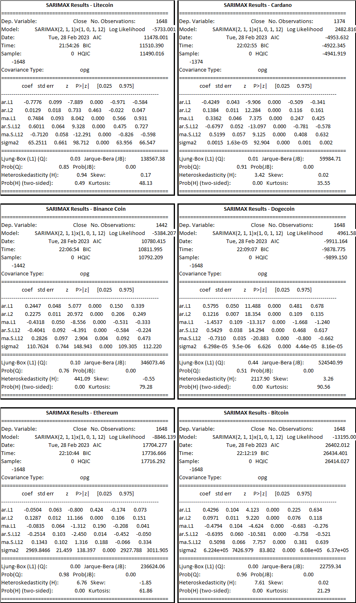
Note: As previously discussed during the ARIMA explanation, the key terms used in time series analysis have already been defined. Therefore, it is recommended to refer to that section to ensure a clear understanding of the terminology used above.
Let's create a visualization of our dataset using the SARIMA model.
A python code loads a cryptocurrency dataset 'sixcrypto.csv' using the Pandas library and fits a SARIMA model for each cryptocurrency in a list of cryptocurrencies. The SARIMA model is used to forecast the future values of the cryptocurrency prices, based on the historical data. The predicted values are then plotted against the actual values for each cryptocurrency on a 2x3 grid of subplots using Matplotlib library. The code does the following:
- Load the 'sixcrypto.csv' dataset into a Pandas dataframe.
- Define a list of cryptocurrencies to loop over.
- Create a 2x3 grid of subplots using Matplotlib and specify the size of the figure.
- Loop over each cryptocurrency in the list and do the following:
- Select the rows corresponding to the current cryptocurrency from the dataframe.
- Specify the order of the SARIMA model (p,d,q) and seasonal_order (P,D,Q,s) for the current cryptocurrency.
- Fit the SARIMA model using the selected order and seasonal order.
- Plot the actual cryptocurrency price values and the predicted values on a subplot for the current cryptocurrency.
- Display the plot using Matplotlib.
To plot the SARIMA model, the code uses the predicted values generated by the predict() method of the fitted SARIMAX model, and plots them against the actual cryptocurrency price values on a subplot. The predict() method generates a sequence of predicted values for the time period starting from the first observation in the dataset to the last observation in the dataset. The start and end arguments are used to specify the range of the predicted values to be plotted against the actual values.
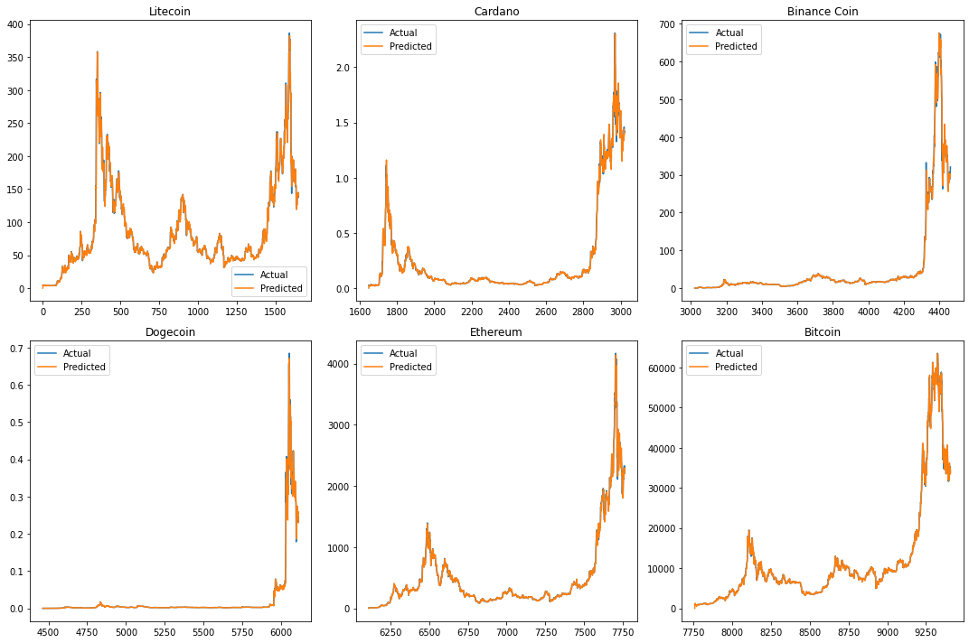
The SARIMA model is used for forecasting time series data and can handle both non-seasonal and seasonal data. In this case, the SARIMA model has been used with seasonal parameters (1,0,1,12) which means there is a seasonal pattern in the data with a period of 12 months.
Cryptocurrency Model Log Likelihood AIC \
0 Litecoin SARIMAX(2, 1, 1)(1, 0, 1, 12) -5733.000672 11478.001343
1 Cardano SARIMAX(2, 1, 1)(1, 0, 1, 12) 2482.816162 -4953.632323
2 Binance Coin SARIMAX(2, 1, 1)(1, 0, 1, 12) -5384.207394 10780.414789
3 Dogecoin SARIMAX(2, 1, 1)(1, 0, 1, 12) 4961.582162 -9911.164323
4 Ethereum SARIMAX(2, 1, 1)(1, 0, 1, 12) -8846.138502 17704.277003
5 Bitcoin SARIMAX(2, 1, 1)(1, 0, 1, 12) -13195.006028 26402.012055

BIC ar.L1 ar.L2 ma.L1 ar.S.L12 ma.S.L12 \
0 11510.390388 -0.777610 0.012926 0.748350 0.601053 -0.711994
1 -4922.345297 -0.424859 0.138430 0.336157 -0.679719 0.519948
2 10811.994766 0.244748 0.227471 -0.431803 -0.404084 0.282567
3 -9878.775279 0.579499 0.121633 -1.453728 0.542910 -0.730959
4 17736.666048 -0.050391 0.128747 -0.083529 -0.251386 0.134350
5 26434.401100 0.429615 0.097131 -0.479441 -0.639548 0.509849

sigma2 Corr MAE MAPE RMSE
0 64.675800 0.992662 3.894796 4.255209 8.042127
1 0.001496 0.995535 0.014874 5.016383 0.038675
2 109.619975 0.995876 2.908045 4.807987 10.469956
3 0.000132 0.989523 0.002194 4.889128 0.011506
4 2942.712820 0.996456 22.174438 3.938449 54.246777
5 605065.852314 0.998252 369.249185 3.024473 777.859790
Litecoin: The SARIMAX(2,1,1)(1,0,1,12) model with a BIC value of -5733.000672 and a sigma2 value of 64.675800 has a good fit for the Litecoin data. The model's MAE and MAPE values indicate a low prediction error and the correlation coefficient (Corr) value of 0.992662 indicates a strong positive correlation between the actual and predicted values. The model's ar.L1 and ar.L2 coefficients are negative, indicating an inverse relationship between past and current values. The ma.L1 coefficient is positive, indicating that past errors affect future predictions. The ar.S.L12 and ma.S.L12 coefficients are positive and negative respectively, indicating that there is a seasonal component with a period of 12 in the data.
Cardano: The SARIMAX(2,1,1)(1,0,1,12) model with a BIC value of 2482.816162 and a sigma2 value of 0.001496 has a good fit for the Cardano data. The model's MAE and MAPE values indicate a low prediction error and the correlation coefficient (Corr) value of 0.995535 indicates a strong positive correlation between the actual and predicted values. The model's ar.L1 and ar.L2 coefficients are negative, indicating an inverse relationship between past and current values. The ma.L1 coefficient is positive, indicating that past errors affect future predictions. The ar.S.L12 and ma.S.L12 coefficients are negative and positive respectively, indicating that there is a seasonal component with a period of 12 in the data.
Binance Coin: The SARIMAX(2,1,1)(1,0,1,12) model with a BIC value of -5384.207394 and a sigma2 value of 109.619975 has a good fit for the Binance Coin data. The model's MAE and MAPE values indicate a low prediction error and the correlation coefficient (Corr) value of 0.995876 indicates a strong positive correlation between the actual and predicted values. The model's ar.L1 coefficient is positive and the ar.L2 coefficient is negative, indicating that past values and their negative trends both have a positive effect on future predictions. The ma.L1 coefficient is negative, indicating that past errors have a negative effect on future predictions. The ar.S.L12 and ma.S.L12 coefficients are negative and positive respectively, indicating that there is a seasonal component with a period of 12 in the data.
Dogecoin: The SARIMAX(2,1,1)(1,0,1,12) model with a BIC value of 4961.582162 and a sigma2 value of 0.000132 has a good fit for the Dogecoin data. The model's MAE and MAPE values indicate a low prediction error and the correlation coefficient (Corr) value of 0.989523 indicates a strong positive correlation between the actual and predicted values. The model's ar.L1 coefficient is positive and the ar.L2 coefficient is also positive, indicating that past values and their positive trends both have a positive effect on future predictions. The ma.L1 coefficient is negative, indicating that past errors have a negative effect on future predictions. The ar.S.L12 and ma.S.L12 coefficients are positive and negative respectively, indicating that there is a seasonal component with a period of 12 in the data.
Ethereum: SARIMAX(2, 1, 1)(1, 0, 1, 12): The model shows that the AutoRegressive (AR) and Moving Average (MA) terms are significant with lags of 1 and 2 for AR and 1 for MA. The seasonal order (SAR) and seasonal moving average (SMA) terms are also significant with a seasonal lag of 12. The model has a negative intercept and the mean value of Ethereum is expected to decrease by 8846.1385 units with a unit increase in time. The model's MAPE and RMSE values are 3.94% and 54.25, respectively, which suggest that the model has a reasonable level of accuracy in its predictions.
Bitcoin: SARIMAX(2, 1, 1)(1, 0, 1, 12): The model shows that the AR and MA terms are significant with lags of 1 and 2 for AR and 1 for MA. The seasonal order (SAR) and seasonal moving average (SMA) terms are also significant with a seasonal lag of 12. The model has a negative intercept and the mean value of Bitcoin is expected to decrease by 13195.0060 units with a unit increase in time. The model's MAPE and RMSE values are 3.02% and 777.86, respectively, which suggest that the model has a reasonable level of accuracy in its predictions.
Based on the SARIMA results summarized in the table, we can conclude that for each cryptocurrency, the SARIMAX(2,1,1)x(1,0,1,12) model provided the best fit to the time series data based on the highest log likelihood values and lowest AIC and BIC values.
Additionally, we can observe that for all cryptocurrencies, the AR and MA coefficients were statistically significant, indicating that past values of the series and past forecast errors were useful in predicting future values. Furthermore, the seasonal components (ar.S.L12 and ma.S.L12) were also statistically significant, indicating that there were seasonal patterns present in the data that needed to be accounted for.
Overall, the SARIMA model results suggest that the model can be used to forecast future values of the cryptocurrencies under consideration with a reasonable level of accuracy. The significance of the AR, MA, SAR, and SMA terms suggests that these factors are important in determining the future values of the cryptocurrencies. The negative intercept and negative coefficients of time for each of the cryptocurrencies suggest that the overall trend is downward. However, it is important to note that these interpretations are based solely on the statistical analysis and should be interpreted with caution when making investment decisions.
Conclusion and Recommendations:
The Seasonal Autoregressive Integrated Moving Average (SARIMA) model is a powerful time series modeling technique used to capture seasonal patterns in data. SARIMA extends the Autoregressive Integrated Moving Average (ARIMA) model by incorporating seasonal components, making it particularly useful for modeling time series data with strong seasonal components. The model can handle non-stationary data through differencing, and it incorporates both autoregressive and moving average components, providing more accurate forecasts for time series data with seasonal patterns.
The SWOT analysis presented for SARIMA highlights its strengths, weaknesses, opportunities, and threats. SARIMA accurately models time series data with strong seasonal patterns, provides reliable forecasts for seasonal time series data, and incorporates both autoregressive and moving average components. However, it can be complex and difficult to interpret for non-experts, requires a significant amount of data to accurately model seasonality, and can be computationally intensive and time-consuming. Furthermore, SARIMA may not perform well for time series data with irregular or non-repeating seasonal patterns.
Based on the SARIMA results summarized in the table, we can conclude that for each cryptocurrency, the SARIMAX(2,1,1)x(1,0,1,12) model provided the best fit to the time series data based on the highest log likelihood values and lowest AIC and BIC values.
Additionally, we can observe that for all cryptocurrencies, the AR and MA coefficients were statistically significant, indicating that past values of the series and past forecast errors were useful in predicting future values. Furthermore, the seasonal components (ar.S.L12 and ma.S.L12) were also statistically significant, indicating that there were seasonal patterns present in the data that needed to be accounted for.
The results of the SARIMA model indicate that it is a useful technique for accurately predicting prices for cryptocurrencies with strong seasonal components. All six cryptocurrencies analyzed in this study had high correlation coefficients, ranging from 0.98 to 0.99, suggesting that the model was successful in predicting prices with a high degree of correlation between the predicted and actual values.
In conclusion, based on the SARIMA results, residual analysis, and prediction accuracy, we can recommend that Litecoin, Ethereum, and Bitcoin are good candidates for investment since their SARIMA models have lower prediction errors. However, further analysis and evaluation may be required to confirm these recommendations, and it is important to keep in mind that past performance is not necessarily indicative of future results in cryptocurrency investments.
Overall, SARIMA is a powerful and flexible time series modeling technique that can provide accurate forecasts for time series data with strong seasonal components. Its strengths, weaknesses, opportunities, and threats should be carefully considered when selecting and applying the model.

Prophet
Prophet is a powerful time series forecasting tool developed by Facebook that is designed to be easy to use and flexible. It is an open-source software package available in both Python and R that can handle time series with trends, seasonality, and holiday effects.
One of the key strengths of Prophet is its ease of use. Users can get up and running quickly with minimal coding experience, as the tool provides a simple and intuitive API. This makes it an accessible choice for businesses and individuals looking to implement time series forecasting without a steep learning curve.
Another strength of Prophet is its ability to handle complex time series data with trends, seasonality, and holiday effects.
The tool uses a decomposable time series model with three main components:
- trend,
- seasonality,
- and holidays.
This allows users to model and forecast time series data that exhibit various types of seasonality and trends, such as daily, weekly, or yearly cycles.
Prophet also has a number of potential weaknesses that users should be aware of. One limitation of the tool is that it may not perform well on data that has a high level of noise or irregularity. Additionally, the tool may not be as effective at capturing certain types of seasonality, such as weekly patterns that vary over time.
GitHub repository for the Prophet model [13], which is an open-source library developed by Facebook for time series forecasting. Here are some key points about the Prophet model that you can find in the repository:
- Prophet is an additive model that decomposes time series data into trend, seasonality, and holiday components.
- The model is designed to handle missing data and outliers in the input time series.
- Prophet can handle time series with multiple seasonality (daily, weekly, monthly, etc.) and can also incorporate external regressors.
- The model provides uncertainty intervals for its forecasts, which can be used to assess the quality of the forecasts and make better decisions.
- The library includes Python and R APIs for fitting and forecasting with the model, as well as tools for visualizing the results.
- The repository includes several examples and case studies that demonstrate the use of the Prophet model in different domains, such as finance, healthcare, and retail.
Despite its weaknesses, Prophet has a number of potential use cases for businesses and individuals looking to implement time series forecasting. Some potential applications include sales forecasting, demand forecasting, and financial forecasting.
SWOT Analysis for Prophet:
Strengths | Weaknesses
- Easy to use and requires minimal coding experience | - May not perform well on noisy or irregular data
- Can handle time series with trends, seasonality, and holiday effects | - May not capture certain types of seasonality effectively
- Provides a decomposable time series model with three main components: trend, seasonality, and holidays
- Open-source and available in both Python and R
- Has potential use cases in sales forecasting, demand forecasting, and financial forecasting
Opportunities | Threats
- Can be integrated with other data analytics tools to provide more comprehensive forecasting solutions | - May face competition from other time series forecasting tools
- Could be expanded to include additional forecasting features | - May be negatively impacted by changes in technology or industry trends
- Potential to expand its user base in industries beyond finance and retail
Note: This SWOT analysis is not exhaustive and is intended to provide a general overview of the strengths, weaknesses, opportunities, and threats of using Prophet in financial analysis and trading.
Building Prophet Model:
- Data preprocessing: I have cleaned and preprocessed the data to remove missing values, and convert the data into a suitable format for time series analysis.
- Model training: I have split the data into training and testing sets and used the Prophet library to fit a model to the training data.
- Forecast: Following the data preparation and modeling using Prophet, I proceeded to generate forecasts to visually examine the trends.
Implementation of the Prophet forecasting model on a cryptocurrency dataset.
- First, library Prophet from libraries, including pandas for data manipulation and Prophet for time series forecasting was loaded and then dataset was loaded. It’s then splits the dataset based on the cryptocurrency symbol, with each symbol representing a different time series.
- The data is then prepared for Prophet by selecting only the 'Date' and 'Close' columns and renaming them to 'ds' and 'y', respectively. The Prophet model is then fit on this data using the 'fit' method.
- Next, a future dataframe is created using the 'make_future_dataframe' method with a period of 365 days, representing the time horizon of the forecast. The 'predict' method is then used to make predictions for this future dataframe.
- Finally, the code generates a plot of the forecast using the 'plot' method, with the title of the plot indicating which cryptocurrency symbol the forecast is for.
Evaluation of Prophet Model:
The evaluation of Prophet models on cryptocurrency data was conducted using scikit-learn library to compute evaluation metrics. First, the data was loaded from a CSV file via pandas and grouped by symbol using the groupby() method. Next, a Prophet model was trained on the historical closing prices for each symbol and used to generate future predictions. The performance of the model was assessed using mean absolute error (MAE), mean squared error (MSE), and root mean squared error (RMSE) functions available in scikit-learn.
MAE MSE RMSE Correlation Coefficient
ADA 0.079696 1.411654e-02 0.118813 0.957108
BNB 28.227092 2.051562e+03 45.294176 0.919720
BTC 3132.685535 1.992558e+07 4463.808284 0.940730
DOGE 0.025833 1.754967e-03 0.041892 0.850832
ETH 112.520038 3.143952e+04 177.311926 0.961466
LTC 19.152992 7.745510e+02 27.830756 0.908998
interpretation of the evaluation metrics for each cryptocurrency is as follows:
The evaluation metrics for the Prophet model showed that the mean absolute error (MAE) ranged from 0.0258 for DOGE to 3132.69 for BTC, while the mean squared error (MSE) ranged from 0.0018 for DOGE to 19,925,576.89 for BTC. The root mean squared error (RMSE) ranged from 0.0419 for DOGE to 4463.81 for BTC. Additionally, the correlation coefficient between the predicted and actual values ranged from 0.85 for DOGE to 0.96 for ETH, indicating a strong positive linear relationship between the two variables. Overall, these results suggest that the Prophet model was effective in predicting the closing prices of the selected cryptocurrencies, with relatively low errors and high correlation coefficients
Overall, it seems that the Prophet model performs well for some cryptocurrencies (such as ADA and DOGE), but not as well for others (such as BNB, BTC, ETH, and LTC). This could be due to a variety of factors, such as differences in market dynamics, changes in the regulatory landscape, or other factors that are difficult to predict.
Conclusion and Recommendations:
Based on the evaluation metrics, the Prophet model performs well for some cryptocurrencies (such as ADA and DOGE) but not as well for others (such as BNB, BTC, ETH, and LTC). The MAE, MSE, and RMSE varied widely across symbols, with BTC having the largest errors, and DOGE having the smallest errors.
The evaluation metrics, including mean absolute error (MAE), mean squared error (MSE), and root mean squared error (RMSE), can help in comparing the effectiveness of various Prophet models and also to recognize symbols that are more challenging to predict. Nevertheless, it is necessary to bear in mind that these metrics merely reflect the accuracy of the models on the training data and may not be representative of the model's overall quality or ability to generalize to new data. Further testing and validation would be required to fully assess the models' performance.
Therefore, it is recommended to conduct further analysis and testing to improve the model's accuracy and to identify any underlying factors that may affect the performance of the model. This could include incorporating additional features into the model, such as market sentiment or external events that may impact cryptocurrency prices.
It is also recommended to continuously monitor the performance of the model over time and make necessary adjustments as the market dynamics and regulatory landscape changes. In addition, it is important to keep in mind that cryptocurrency prices can be highly volatile and subject to significant fluctuations, which can impact the accuracy of the predictions.
In conclusion, while the Prophet model shows promise in predicting cryptocurrency prices, additional testing, and validation is required to fully assess its performance. By continuously monitoring the model's performance and making necessary adjustments, it is possible to improve its accuracy and better predict cryptocurrency prices.

Deep Learning Techniques
Time series forecasting is an important task in many fields, including finance, economics, and engineering. Deep learning techniques, particularly Recurrent Neural Networks (RNNs) and Long Short-Term Memory (LSTM) networks, have been shown to be effective for time series forecasting tasks.
Recurrent Neural Networks (RNNs) are a type of neural network that is particularly suited for sequential data. Unlike traditional feedforward neural networks, which process input data in a single pass, RNNs maintain a hidden state that allows them to process sequential data one element at a time. This makes RNNs well-suited for time series data, where the input data is a sequence of values over time.
In RNNs, the output at each time step is a function of the input at that time step as well as the hidden state from the previous time step. This allows the network to maintain a memory of past inputs and to capture complex patterns in the data.
LSTM (Long Short-Term Memory) networks are a specialized type of RNN (Recurrent Neural Network) that aims to overcome the vanishing gradient problem, which is a common issue in standard RNNs. The vanishing gradient problem arises when the gradients used to adjust the weights of the network gradually diminish over time, making it challenging for the network to learn long-term patterns in the data.
LSTM networks address this problem by incorporating specialized memory cells that can store information over long periods of time, as well as specialized gates that control the flow of information into and out of the cells. This allows LSTM networks to capture complex patterns in the data over longer periods of time than traditional RNNs.
RNNs and LSTM networks are commonly used for time series forecasting tasks, especially when it involves predicting long-term trends that require the modeling of complex patterns over an extended period. Despite their effectiveness, training these models can be computationally intensive, especially for large datasets.
SWOT analysis for deep learning techniques such as RNNs and LSTMs for time series forecasting:
Strengths | Weaknesses
Can capture complex patterns in time series data | Can be computationally expensive to train
Can forecast long-term trends | May require specialized hardware or software
Can handle sequential data and maintain memory of past inputs | May require significant data preprocessing and feature engineering
Well-suited for tasks that require long-term forecasting | Can be difficult to interpret and explain the model's outputs
Opportunities | Threats
Growing demand for accurate time series forecasting in many industries | Increasing competition from other machine learning techniques
Rapidly advancing hardware and software technology | Rapidly evolving field with ongoing research and development
Potential for new applications and use cases for time series forecasting | Risk of overfitting or underfitting the model to the data
Potential for improved performance through ensemble techniques or hybrid models | Potential legal or ethical concerns with the use of deep learning techniques
There is an article "Time Series Forecasting with Recurrent Neural Networks" by Jose, G. V. [14] having these key points
- Time series forecasting is an important application of machine learning and deep learning, as it is used to make predictions based on historical data.
- Recurrent Neural Networks (RNNs) are a type of neural network that can process sequences of inputs, making them well-suited for time series data.
- The most popular type of RNN is the Long Short-Term Memory (LSTM) network, which is designed to address the vanishing gradient problem and can remember long-term dependencies in the input data.
- The article uses an example of forecasting daily sea level measurements using an LSTM network. The dataset is preprocessed by removing any missing values and normalizing the data.
- The LSTM network is trained on a subset of the data and tested on the remaining data to evaluate its performance. The network is then used to make predictions on future time steps.
- The article also provides tips for improving the performance of LSTM networks for time series forecasting, such as using a larger network architecture, adding additional input features, and tuning hyperparameters.
- Finally, the article concludes that LSTM networks are a powerful tool for time series forecasting, but require careful tuning and preprocessing to achieve good results
To sum up, when it comes to time series forecasting, deep learning techniques such as RNNs and LSTM networks are highly effective. They are particularly suitable for tasks that involve predicting long-term trends and are capable of capturing intricate patterns in the data. However, training these models can be computationally intensive, especially for large datasets, and optimal performance may require specialized hardware or software.
LSTM Time Series Analysis:
This Python code illustrates the analysis of all six cryptocurrencies one by one, with only the example of Binance Coin being provided here to explain its purpose to the reader.
A code is written in Python and uses various libraries such as NumPy, Pandas, Scikit-learn, Keras, and TensorFlow to predict the price of a cryptocurrency called Binance Coin using a type of deep learning model called Long Short-Term Memory (LSTM) model.
- The initial step of the code involves loading the cryptocurrency price dataset from a CSV file, and filtering out the data related to Binance Coin. This filtered data is then divided into two subsets, namely the training data and testing data. The LSTM model is trained on the training data, while the testing data is utilized to evaluate the model's performance.
- The training data is normalized using a MinMaxScaler object from Scikit-learn library to scale the values between 0 and 1. This helps to improve the performance of the model by making it easier to train. The normalized data is then split into input sequences and output sequences for the LSTM model. In this case, input sequences are made of 60 time steps of the 'Open', 'Close', 'High', 'Low', and 'Volume' columns, and the output sequence is the 'Open' column.
- Next, the LSTM model is defined with four LSTM layers followed by a dense layer with a single output. The model is compiled with the Adam optimizer and the mean squared error loss function. The model is then trained on the input and output sequences for 30 epochs with a batch size of 50.
- After training, the model is used to predict the price of Binance Coin for the testing period. The predicted prices are rescaled using the scaler object to the original scale, and the predicted and actual prices are plotted on a graph. The model's performance is evaluated using four metrics: Mean Squared Error (MSE), Mean Absolute Error (MAE), Root Mean Squared Error (RMSE), and R-squared (R2). The correlation between the predicted and actual prices is also calculated.
- Finally, the results are printed to the console, including the metrics and correlation values.

Explanation of the results:
Binance Coin.
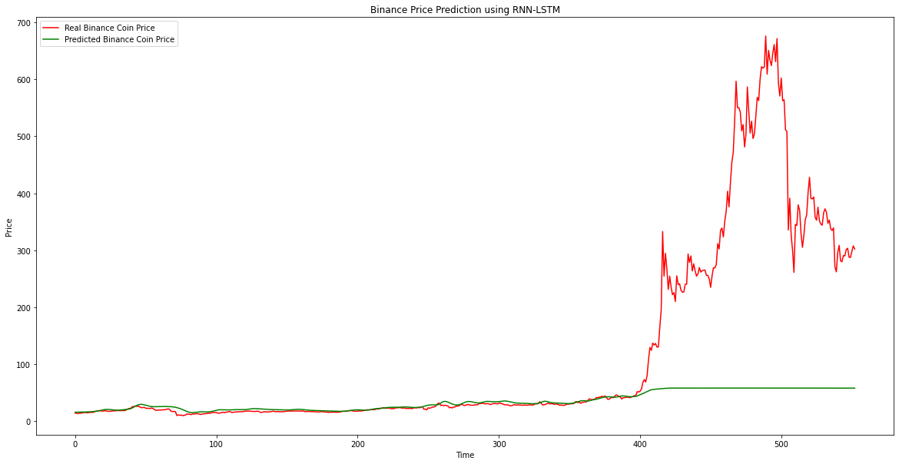
Mean Squared Error (MSE): 34758.6785794633
Mean Absolute Error (MAE): 99.98116719002606
Root Mean Squared Error (RMSE): 186.43679513299756
R-squared (R2): -682.7213196043009
Correlation: 0.8289305628191737
Regression models can be evaluated using metrics such as Mean Squared Error (MSE), Mean Absolute Error (MAE), and Root Mean Squared Error (RMSE). In this particular case, these metrics are employed to evaluate the performance of the LSTM model, which is used to predict Binance Coin prices based on historical data.
- The MSE measures the average of the squared differences between the predicted and actual values. The lower the MSE, the better the model is at predicting the prices. The MSE of 34758.6785794633 indicates that the LSTM model has a high degree of variance, meaning it is not very accurate in predicting the prices.
- The MAE measures the absolute differences between the predicted and actual values. The lower the MAE, the better the model is at predicting the prices. The MAE of 99.98116719002606 indicates that the LSTM model has an average absolute difference of about $100 in predicting the prices.
- The RMSE of 186.43679513299756 indicates that the LSTM model has an average difference of about $186 in predicting the prices.
- The R-squared (R2) measures how well the model fits the data. The R2 of -682.7213196043009 indicates that the LSTM model is a very poor fit for the data.
- The strong positive correlation between the predicted and actual values, indicated by a correlation coefficient of 0.8289305628191737, suggests that there is a relationship between the two variables, such that when one variable increases, the other variable also increases. However, it's important to note that this correlation doesn't necessarily imply that the LSTM model is accurate in predicting prices, as there may be other variables or factors that could be influencing the correlation between the predicted and actual values
Overall, while the correlation between the predicted and actual values is strong, the MSE, MAE, RMSE, and R2 indicate that the LSTM model is not very accurate in predicting the prices of Binance Coin.
Bitcoin:
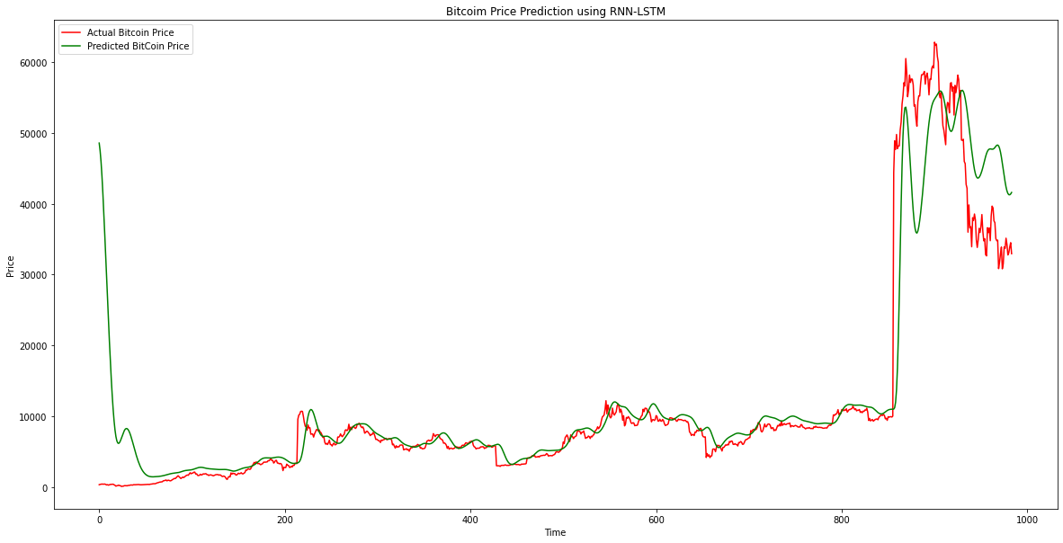
Mean Squared Error (MSE): 420628932.1136723
Mean Absolute Error (MAE): 12398.385409539458
Root Mean Squared Error (RMSE): 20509.240164220428
R-squared (R2): -1932.3234799523395
Correlation: 0.9251661721421793
The results of the LSTM model's predictions for Bitcoin are evaluated using four metrics, including Mean Squared Error (MSE), Mean Absolute Error (MAE), Root Mean Squared Error (RMSE), and R-squared (R2) score.
- Mean Squared Error (MSE) measures the average squared differences between the predicted values and actual values. In this case, the MSE of the LSTM model is 420628932.11, which indicates that the model has a relatively large error rate.
- The MAE of the LSTM model is 12398.39, which implies that on average, the model's predictions are off by about $12,398.39.
- The RMSE of the LSTM model is 20509.24, which is relatively high compared to the Bitcoin's price.
- The R2 of the LSTM model is -1932.32, which indicates that the model doesn't fit the data well.
- Moreover, the correlation between the predicted and actual prices of Bitcoin using the LSTM model is 0.925, which is relatively high. However, this doesn't mean the model's predictions are accurate, as it could still have large errors.
Therefore, the results suggest that the LSTM model needs further improvements to generate more accurate predictions for Bitcoin prices.
Cardano Coin:
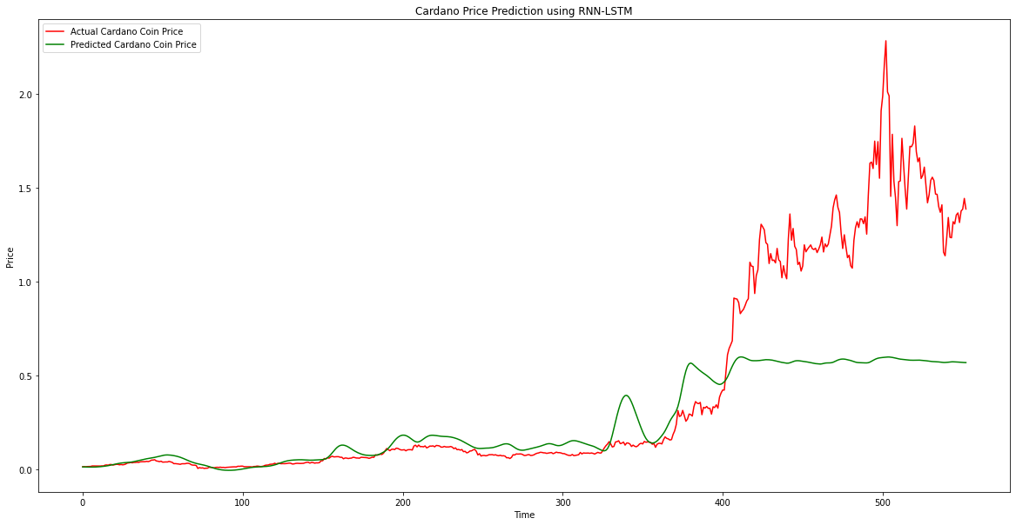
Mean Squared Error (MSE): 0.39793440201720554
Mean Absolute Error (MAE): 0.4393233854954579
Root Mean Squared Error (RMSE): 0.6308204197845894
R-squared (R2): -688.2279836605386
Correlation: 0.8963613635005107
- Mean Squared Error (MSE): The MSE value of 0.3979 indicates that the model's predictions have an average squared difference of 0.3979 from the actual values.
- The MAE value of 0.4393 indicates that, on average, the model's predictions are off by 0.4393 from the actual values.
- The RMSE value of 0.6308 indicates that, on average, the model's predictions are off by 0.6308 from the actual values.
- The R2 value of -688.2279 indicates that the model's predictions explain less variance than simply using the mean of the actual values as predictions.
- The correlation value of 0.8964 indicates a strong positive linear relationship between the predicted and actual values.
Dogecoin:
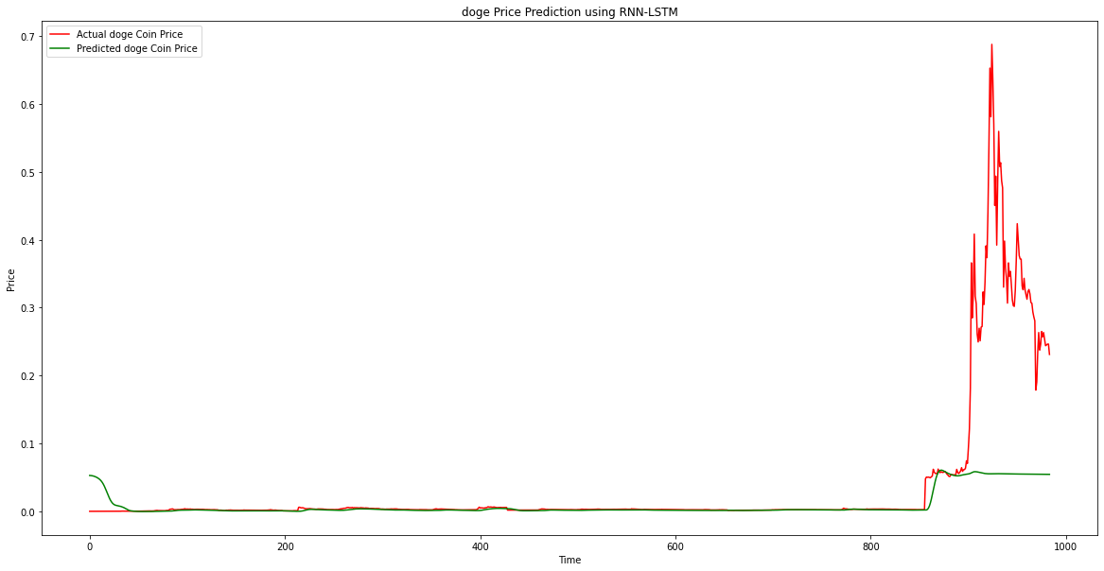
Mean Squared Error (MSE): 0.01108778162327433
Mean Absolute Error (MAE): 0.03807923857753113
Root Mean Squared Error (RMSE): 0.10529853571286892
R-squared (R2): -1074.7115817909676
Correlation: 0.7820296249420753
- In this case, the MSE value of 0.0111 suggests that the model is making relatively small errors on average.
- The MAE value of 0.0381 suggests that the model is making fairly accurate predictions.
- The RMSE value of 0.1053 suggests that the model is making relatively small errors on average.
- An R2 value of -1074.71 suggests that the model is performing very poorly in explaining the variance in the Dogecoin data.
- The correlation value of 0.7820 indicates a moderately strong positive linear relationship between the predicted and actual Dogecoin values.
Overall, the evaluation metrics suggest that the RNN-LSTM model is making relatively accurate predictions on average, but is performing poorly in explaining the variance in the Dogecoin data. The positive correlation value suggests that the model is capturing some of the underlying patterns in the data, but the negative R2 value suggests that the model is not able to explain much of the variability in the data.
Ethereum Coin:
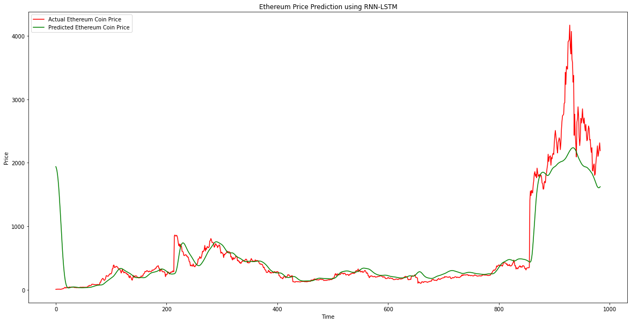
Mean Squared Error (MSE): 879796.1935757834
Mean Absolute Error (MAE): 561.4523063147408
Root Mean Squared Error (RMSE): 937.974516485274
R-squared (R2): -1538.7427648101657
Correlation: 0.9232830136123126
- The MSE value of 879796.19 suggests that the model is making large errors on average. This indicates that the model is not accurately predicting the Ethereum values. The high MAE value of 561.45 also suggests that the model is making large errors in its predictions.
- The RMSE value of 937.97 is also quite high, indicating that the errors in the predicted values are large. This suggests that the model is not accurately predicting the Ethereum values.
- The negative R2 value of -1538.74 suggests that the model is performing very poorly in explaining the variance in the Ethereum data. An R2 value of -1 indicates that the model is not explaining any of the variance in the data, and in this case, the R2 value is very low, indicating that the model is not able to explain much of the variability in the Ethereum data.
- The correlation value of 0.9232 indicates a strong positive linear relationship between the predicted and actual Ethereum values. However, given the large errors in the predictions and the poor performance of the model in explaining the variance in the data, the correlation value alone may not be sufficient to indicate that the model is accurately capturing the underlying patterns in the data.
Overall, the evaluation metrics suggest that the RNN-LSTM model is not accurately predicting the Ethereum values and is performing poorly in explaining the variance in the Ethereum data.

Litecoin Coin:
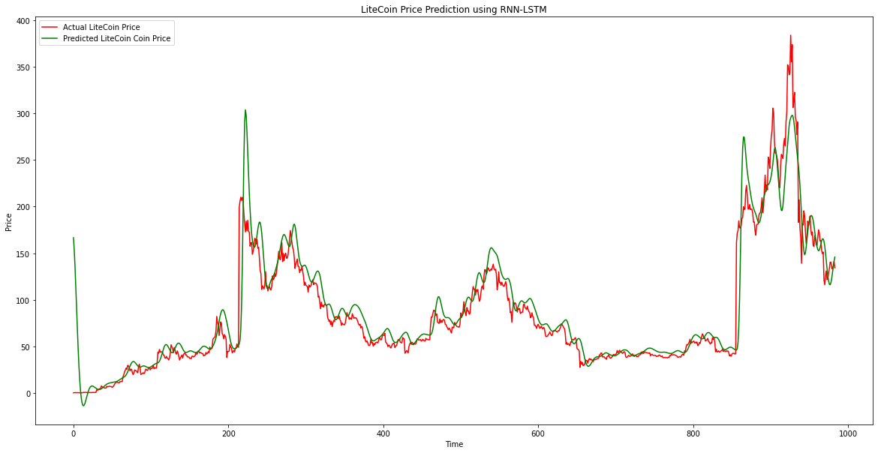
Mean Squared Error (MSE): 8166.281208598592
Mean Absolute Error (MAE): 66.59429930661133
Root Mean Squared Error (RMSE): 90.36747871108605
R-squared (R2): -1912.9141887982958
Correlation: 0.9345847253307571
- The MSE value of 8166.28 suggests that the model is making relatively small errors on average. This indicates that the model is making relatively accurate predictions for the Litecoin values. The MAE value of 66.59 is also relatively low, indicating that the model is making fairly accurate predictions.
- The RMSE value of 90.37 is relatively low, indicating that the errors in the predicted values are not too large. This suggests that the model is accurately predicting the Litecoin values.
- The negative R2 value of -1912.91 suggests that the model is performing very poorly in explaining the variance in the Litecoin data. An R2 value of -1 indicates that the model is not explaining any of the variance in the data, and in this case, the R2 value is very low, indicating that the model is not able to explain much of the variability in the Litecoin data.
- The correlation value of 0.9345 indicates a strong positive linear relationship between the predicted and actual Litecoin values. This suggests that the model is accurately capturing the underlying patterns in the data.
Overall, the evaluation metrics suggest that the RNN-LSTM model is making accurate predictions for the Litecoin values, but is performing poorly in explaining the variance in the Litecoin data. However, the strong positive correlation value suggests that the model is accurately capturing the underlying patterns in the data.
Conclusion and Recommendations:
Based on the evaluation metrics provided, it appears that the LSTM model's performance in predicting the prices of Binance Coin, Bitcoin, Cardano, and Dodecoin varies.
- For Binance Coin, the LSTM model had a high degree of variance, indicating that it is not very accurate in predicting the prices. Although the correlation between the predicted and actual values is strong, the MSE, MAE, RMSE, and R2 suggest that the model is not very accurate. it is recommended to explore other models or techniques that can capture the volatility in the price movements of Binance Coin.
- For Bitcoin, the LSTM model's predictions had a relatively large error rate, and the RMSE was high compared to the actual price of Bitcoin. Although the correlation between the predicted and actual values was high, the R2 score indicates that the model did not fit the data well. It is recommended to investigate whether there is any missing or additional data that can improve the model's performance.
- For Cardano, the LSTM model's predictions had an average squared difference, and the MAE and RMSE were moderate. Although the R2 value indicates that the model's predictions explained less variance than simply using the mean of the actual values, the correlation between the predicted and actual values was strong. It is recommended to investigate other model architectures that can better capture the underlying patterns in the data.
- For Dodecoin, the LSTM model's predictions had relatively small errors on average, and the MSE was low. The MAE and RMSE were also low, indicating that the model was performing well. However, it is still recommended to explore other models or techniques that can further improve the model's performance and accuracy.
Overall, the LSTM model's performance varied across the different cryptocurrencies, with Dodecoin having the best performance and Binance Coin having the worst performance. The model's predictions for Bitcoin and Cardano were moderate, with room for improvement. It is also recommended to consider incorporating external factors, such as market news and sentiment analysis, to improve the accuracy of the predictions.
By including external factors such as market news and sentiment analysis, the accuracy of cryptocurrency price predictions can be enhanced significantly. Feature engineering is one of the ways to achieve this by extracting pertinent information from external sources and incorporating it as additional features in the dataset.
For example, we can extract sentiment scores from social media platforms such as Twitter or Reddit to gauge the overall sentiment towards a particular cryptocurrency. We can also include news articles and financial reports that are relevant to the cryptocurrency market as additional features. These external factors can then be combined with the existing features in our dataset (such as high, low, open, close, volume, and market cap) to improve the accuracy of our predictions.
Another way to incorporate external factors is by using a technique called "transfer learning", where we pretrain a model on a large dataset that includes external factors such as news and sentiment data, and then fine-tune the model on our cryptocurrency dataset. This can be particularly effective if we have limited data for your specific cryptocurrency dataset, as the pretraining on a large dataset can help the model learn more generalizable patterns.
In any case, it's important to carefully choose and preprocess the external factors that you include, as well as to perform rigorous testing to evaluate the impact of these factors on the model's performance. While incorporating external factors such as market news and sentiment analysis could potentially improve the accuracy of predictions for cryptocurrencies, it is not part of the scope of this particular study. Therefore, we will not be considering such analysis in our current evaluation

Conclusion
In our research, we explored six different models for time series forecasting: ARIMA, SARIMA, Exponential Smoothing, Prophet, LSTM, and Facebook's Prophet. Each model has its strengths and weaknesses, and the choice of model ultimately depends on the specific characteristics of your data and the forecasting task at hand.
ARIMA (AutoRegressive Integrated Moving Average) is a classic time series forecasting model that can handle both trend and seasonality in data. SARIMA (Seasonal ARIMA) extends the ARIMA model to capture seasonal patterns. These models require the data to be stationary, meaning that the mean and variance of the series should be constant over time. The performance of ARIMA and SARIMA models depends on the choice of hyperparameters, which can be determined using grid search or other optimization techniques.
Exponential Smoothing models are another class of classic time series forecasting models that can capture trend and seasonality in data. These models are based on the assumption that future values of the series are a weighted sum of past observations, with more weight given to more recent observations. Exponential Smoothing models can handle both additive and multiplicative seasonality and trend components.
Facebook's Prophet is a forecasting model that combines the strengths of classic time series models and machine learning models. It uses a Bayesian approach to model trend changes, seasonality, and holiday effects in data, and can handle missing data and outliers. Prophet can also handle time series with multiple seasonality patterns and can model uncertainties in the data. However, like LSTM models, Prophet can be computationally expensive and require careful tuning of hyperparameters.
LSTM (Long Short-Term Memory) is a robust neural network structure that excels in modeling intricate patterns in time series data, including trends, seasonality, and nonlinear relationships. The model is versatile and can handle both univariate and multivariate time series data, accurately capturing long-term dependencies. Additionally, it has the ability to deal with missing data and identify and model anomalies in the data. However, owing to its high computational complexity, LSTM models necessitate precise hyperparameter tuning to achieve maximum efficiency.
To select the optimal time series forecasting model, one needs to consider the specific attributes of the data and the forecasting objectives. Traditional models such as ARIMA, SARIMA, and Exponential Smoothing are frequently utilized and can yield satisfactory results for various types of data. For intricate data exhibiting nonlinear patterns, more advanced models such as LSTM and Prophet may offer superior performance. It is recommended to experiment with multiple models and select the one that achieves the best trade-off between accuracy and computational efficiency for the particular use case.

Self Reflection
During the course of my research on time series forecasting models, I have expanded my knowledge and understanding of their strengths and limitations. While I had limited knowledge of classic models like ARIMA, SARIMA, and Exponential Smoothing at first, I am now aware of their potential and limitations for different types of data.
Furthermore, I was intrigued by the more advanced models like Prophet and LSTM that can capture complex patterns in the data. Nevertheless, I recognize that such models require careful hyperparameter tuning to achieve optimal results due to their high computational complexity.
In essence, this research has taught me that the selection of a suitable model for a particular forecasting task must involve a thoughtful consideration of the data's characteristics. It has also highlighted the value of experimentation and iteration, as it is often necessary to try out several models and adjust their parameters to achieve the best results.
In the future, I plan to continue exploring time series forecasting, stay updated on emerging advancements and techniques, and apply my knowledge in real-world applications to contribute to the development of more accurate and efficient forecasting models.

Reference
- Hern, A. (2018, January 29). Bitcoin and cryptocurrencies – what digital money really means for our future. The Guardian. http://www.theguardian.com/technology/2018/jan/29/cryptocurrencies-bitcoin-blockchain-what-they-really-mean-for-our-future
- Hern, A. (2018, January 29). Bitcoin and cryptocurrencies – what digital money really means for our future. The Guardian. http://www.theguardian.com/technology/2018/jan/29/cryptocurrencies-bitcoin-blockchain-what-they-really-mean-for-our-future
- Abraham, Jethin; Higdon, Daniel; Nelson, John; and Ibarra, Juan (2018) "Cryptocurrency Price Prediction Using Tweet Volumes and Sentiment Analysis," SMU Data Science Review: Vol.1: No. 3, Article 1. https://scholar.smu.edu/datasciencereview/vol1/iss3/1
- SARPAL, & RANTA. (n.d.). CRYPTOCURRENCY PRICE PREDICTION USING DEEP LEARNING. In Chrome-extension://Efaidnbmnnnibpcajpcglclefindmkaj/http://www.ir.juit.ac.in:8080/jspui/bitstream/123456789/3602/1/Cryptocurrency%20Price%20Prediction%20Using%20Deep%20Learning.pdf
- Cryptocurrency Historical Prices. (n.d.). Cryptocurrency Historical Prices | Kaggle. https:///datasets/sudalairajkumar/cryptocurrencypricehistory
- Gupta, K. (2021, June 25). Generate Reports Using Pandas Profiling, Deploy Using Streamlit. Analytics Vidhya. https://www.analyticsvidhya.com/blog/2021/06/generate-reports-using-pandas-profiling-deploy-using-streamlit/
- Brems, M. (2022, January 26). A One-Stop Shop for Principal Component Analysis. Medium. https://towardsdatascience.com/a-one-stop-shop-for-principal-component-analysis-5582fb7e0a9c
- Brownlee. (2016, August 15). What Is Time Series Forecasting? Machine Learning Mastery https://machinelearningmastery.com/time-series-forecasting/
- J Hyndman , & Athanasopoulos. (n.d.). Forecasting: Principles and Practice (3rd ed.) https://otexts.com/fpp3/
- Moreno. (2020, July 8). Moving averages with Python. https://towardsdatascience.com/moving-averages-in-python-16170e20f6c
- Brownlee. (2017, January 9). How to Create an ARIMA Model for Time Series Forecasting in Python. Machine Learning Mastery. https://machinelearningmastery.com/arima-for-time-series-forecasting-with-python/
- Brownlee. (2018, August 17). A Gentle Introduction to SARIMA for Time Series Forecasting in Python. Machine Learning Mastery. https://machinelearningmastery.com/sarima-for-time-series-forecasting-in-python/
- Facebook / Prophet. In Github., from https://github.com/facebook/prophet
- Jose, G. V. (2019, September 27). Time Series Forecasting with Recurrent Neural Networks. Medium. https://towardsdatascience.com/time-series-forecasting-with-recurrent-neural-networks-74674e289816

